Analyzing the impact of insurance coverage on U.S. mortality

A Preventative forecasting using machine learning models

Akkiraju, harika, 11481127

Gomez, Carlos, 10593138

Norris, Joshua, 11304941

Shrestha, Sabnam, 11446896

Team #3

Submitted to: professor Javier Rubio-Herrero, Ph.D.

2023

Table of Contents

List of Figures 2

Acknowledgements 3

Abstract 4

1. Introduction 5

1.1 Project Goals 5

1.2 Project Roadmap 6

2. Literature Review 6

3. Problem Statement 9

4. Data 10

5. Methodology 14

5.1 Multi-Variable Linear Regression Model 14

5.2. Autoregressive Integrated Moving Average Model (ARIMA) 15

5.3. Random Forest Regression 16

5.5 Support Vector Machine (SVM) 16

5.6 Decision trees 17

6. Results 18

6.1 Multivariable Linear Regression 18

6.1.1 Heart Disease 18

6.1.2 Malignant neoplasms (cancer) 22

6.1.3 Diabetes 25

6.2 Autoregressive Integrated Moving Average Model (ARIMA) 28

6.2.1 The Autocorrelation Function: 30

6.2.2 Determining the Parameters for ARIMA Model. 31

6.3. Random Forest Regression: 33

6.4. Support Vector Machine: 35

6.5. Decision Tree: 35

7. Conclusions 36

7.1 Research Issues and Recommendations 36

7.2 Linear Regression 36

7.3 Autoregressive Integrated Moving Average Model (ARIMA) 37

7.4 Random Forest Regression: 37

7.5. Support Vector Machine 37

8. References 37

9. Authors’ Contributions 40

# List of Figures

Figure 1: U.S. population grouped by insured versus uninsured for 2020 and 2021 13

Figure 2: Population of insured versus uninsured by state for 2020 and 2021 14

Figure 3: Decision tree model overview 18

Figure 4: Heart disease stepwise standard error scoring 19

Figure 5: Heart disease regression output 20

Figure 6: Scatterplot of independent variables where p <0.05, grouped by State_1. Heart disease regression 21

Figure 7: Scatterplot of independent variables where p < 0.05, grouped by State_3. Heart disease regression 22

Figure 8: Malignant neoplasms (cancer) stepwise standard error scoring 23

Figure 9: Cancer regression output 24

Figure 10: Scatterplot of independent variables where p < 0.05, group by State_5. Cancer regression 25

Figure 11: Diabetes stepwise standard error scoring 26

Figure 12: Diabetes regression output 27

Figure 13: Scatterplot of independent variables where p < 0.05. Diabetes regression 28

Figure 14: This code represents the new combined column called “Death by Diseases” which essentially combines all of the deaths by select diseases in the Weekly provisional death count dataset. 29

Figure 15: The line chart that depicts Deaths by combined diseases in the United States in 2020, 2021, 2022 and January and February months of 2023. 29

Figure 16: : The subplots separating the death by diseases visuals for every single year, including partial data for 2023. 30

Figure 17: Death Counts by Diseases over the four years plotted in a logarithmic scale. 30

Figure 18: The First Iteration of the ARIMA model with a (p,d,q) of (1,1,2) 32

Figure 19: Second Iteration of ARIMA model with (p,d,q) of (1,2,2). 32

Figure 20: The ARIMA model Forecasted vs Actual Death by Diseases Comparison Plot 33

Figure 21 Random Forest Regression: Decision Tree Plot 33

Figure 22 Random Forest Regression- Bar plot with Permutation Function 34

Figure 23: SVM Scoring 35

Figure 24: Decision Tree of Uninsured 36

# Acknowledgements

As we close out this chapter in our lives, we look back on our journey to completing our Master’s degree and cannot say thank you enough to all the faculty and staff here at UNT. Without their expertise, guidance, and patience, we would have not been able to finish this program. A special thank you to Professor Rubio-Herrero for all the support and feedback he has given us this past semester.

We are grateful for the classmates over the years but especially those involved in this research paper. Not only did we work together, but we also got to learn more about each other, building friendships that will last for years to come.

Lastly, a huge thank you to our family and friends for their unwavering support during our program. They provided the motivation on days we needed them the most. We hope we have made you proud.

Thank you!

# Abstract

The healthcare system in the United States can be a bit challenging to navigate, especially when compared to similar systems in other first world countries. The average cost of health-related services paid by U.S. residents is $5,000 more than the average of OECD countries. And yet, U.S. residents experience worse health outcomes compared to their peers in other countries. Previous studies have been done using several machine learning procedures to help pinpoint the cause of these worse health outcomes but often, the results are open for interpretation. There were just too many factors to consider when getting definitive answers. Thus, we aimed to analyze the importance and effect of being insured or uninsured along with other demographics on specific causes of death. Some of results we have found indicate that there are pockets of the U.S. population demography that always contribute to many different causes of deaths. These groups need further assistance in ensuring that have the capacity and assistance to not only enroll in medical coverage but continually receive treatment for their ailments.

# 1. Introduction

In 2021, the average healthcare expenditure per person in the U.S. was $12,914, comparatively $5,000 more than other OECD countries [1]. There are many reasons why there is a significant gap between the U.S. and comparable countries, one of them could be how the healthcare system is structured in each country. OECD countries for the most part have a single-payer system, where the bill is footed by the government, meanwhile, the U.S. has multiple payers, with its people paying for a substantial portion of healthcare costs. And even though individuals living in the U.S. spend more on healthcare related costs, they experience worse health outcomes [2]. Tikkanen and Abrams [2] discovered that the U.S. is ranked 1st among OECD countries in the following categories: chronic disease burden, obesity rate, suicide rates, hospitalization count from causes that are preventable and the number of avoidable deaths. These figures alone begin to paint a picture of the U.S. healthcare system, how it is budgeted, managed, and viewed by those that are responsible for the laws related to it. The focus of this research paper is to look at how the U.S. health care industry operates today, the characteristics of the population it serves and how these two affect each other by using updated datasets.

Health insurance covers a portion of an individual’s medical expenses or all necessary expenses in its entirety. Many people naturally receive health insurance through an employer, some from programs provided by the government (Medicaid), and the rest just do not have health insurance altogether [3]. Health insurance is dependent on a multitude of factors, such as: policy changes, economic trends based on location, age, current health status, and whether it is a single household vs. household with dependents. The overarching effects of coverage for people with an underlying/chronic condition can inevitably increase access to preventative services, which directly improves their health. No matter what you believe, lacking coverage is a strong independent risk factor for death [4]. According to the Institute of Medicine’s conclusion [5], the uninsured has a higher probability (0.97) of dying from preventable cause compared to the insured (0.71).

In several studies conducted over the years, the socioeconomic disparity is represented in death rates across the U.S. poverty has led to a lack of health education and increased mortality for individuals with low income. As a result, mortality is higher compared to individuals that are more affluent and better educated [6]. Additionally, a 2016 study showed the disparity in mortality based on location, especially across states further analyzed under rural vs. urban settings. The study states “the age-adjusted all-cause mortality rates in all states except for 3 were higher in rural areas than urban areas with a 30% higher rural mortality compared to urban mortality” [7]. This article has assessed the entire socioeconomic dynamic in mortality between rural and mortality along with mentions of physician shortages and lack of health insurance.

## Project Goals

One of the research goals we have is to determine the effect of health insurance coverage policies on mortality in the U.S. population across different states. We plan to conduct our analysis using U.S. Census data that contains the number of insured and uninsured, in terms of population, and append the insured vs uninsured data with data from the CDC depicting weekly provisional counts of death. One important distinction in our analysis is the spatiotemporal component that includes weekly data, using a smaller period compared to other longitudinal studies in the past. This allows us to factor in rapidly changing socioeconomic landscapes, such as increased insurance premiums, employee layoffs with potential impact on insurance coverage, and insurance provider networking. These issues have not been addressed by earlier studies concerning mortality and insurance coverage. We aim to accomplish this by using two machine learning tools: multivariable linear regression and recurrent neural networks with a focus on time series analysis. Using these two tools will allow us to compare the performance and outputs of the models and decipher any correlations that we may find.

Another research goal is to identify the impact of state initiatives in addressing the leading causes of death, including subsidized plans by states. We plan to perform a classification analysis in determining the leading cause of death by the state. In our preliminary analysis, we have discovered that cardiovascular diseases are a leading cause of death in the U.S. Further research will be done to find patterns surrounding health insurance policies with robust coverage plans for cardiovascular disease and associated mortality rates across states. Additionally, we found that both men and women are equally impacted by this disease [8] and that “when citizens were given free insurance plans, there was an increase in hospital visits and improvement in overall health status” [9]. Thus, by generating a better understanding about the factors responsible for disparity, we aim to support efforts to improve health insurance coverage (private or publicly funded) in states to address mortality.

While separate efforts are being made to address mortality among the low-income and minority groups, there is a need for integrated investigation to study the leading causes of mortality, costs of healthcare for the low-income group, and projection of long-term trends in mortality to address the issue before another major pandemic shakes the foundations of healthcare further. To address the issues of the future, we need models that can dissect the long-term trends in mortality as a direct effect of the most pertinent variables. Thus, we plan to predict the long-term trends in mortality by all causes of death across US states using an integrated autoregressive integrated moving averages (ARIMA) time series forecasting model by incorporating data from the insured and uninsured US populations, characterized by pertinent demographics of employment status, citizenship status, and household income. An understanding of mortality trends from specifically income perspective and income-generating capability will help government initiatives such as Medicare and Medicaid to anticipate and accommodate an accurate population to combat curable causes of death.

As a further means of examination, we aim to analyze and pinpoint the correlation between health insurance with the relative frequency of deaths in a specific geographical location, i.e., States. The analysis will be based heavily on the following: the highest mortality rate of privately insured individuals compared with the uninsured, health insurance availability, age, and household income. Our intentions are to utilize Support vector machines to address classification and regression challenges presented when differentiating between the predefined variables. Alternatively, we’ll incorporate a Correlation matrix to add a broader viewpoint of the presented variable relationships. From Woolhandler and Himmelstein [5], we’ve ascertained that an uninsured patient who is ill or gravely injured struggles to receive care, but having coverage leads to essential preventable care and chronic disease management. Health Insurance is critical to achieving or maintaining adequate health today.

## Project Roadmap

The research paper is organized as follows; a literature review is provided in Section 2 that discusses previous works done on this topic and how we will either fill in gaps or provide edges in this paper; Section 3 layouts the project statement, going over why we are interested in this topic, how we will draw conclusions and why the topic is important; Section 4 describes the data handling and data mining needed to complete the research, this will include appending different datasets from U.S. Census containing insurance status to weekly death counts by state and specific causes of death; Section 5 lays out the project methodology i.e. tools used to accomplish them, regression analysis, neural networks, regressive moving averages, and classifications will be described in detail;

# 2. Literature Review

The research and insights we have gathered in the following section are compiled using the Google Scholar website and the UNT Online Library System, where we used keywords related to U.S. health insurance coverage, premiums, insurance status, state initiatives for health outcomes, health conditions and causes of death in various parts of the U.S. Throughout our research, we aim to provide a comprehensive study that overviews the condition of the healthcare system in the country, including equitable healthcare access, quality of care, costs, and health outcomes. Lastly, we want to identify key areas where improvement is needed to ensure that all individuals have access to affordable and high-quality healthcare.

Previous studies have shown that in 2014, the U.S. reached a historic low of 724.6 all-cause age-adjusted deaths per 100,000 population in 2014 [10] This shows that initiatives to expand publicly funded insurance coverages, such as the Affordable Health Care Act in 2014 [11], do help in improving the health of its insurers. This means that all groups are not affected equally. The same study done by Garcia [10] shows that a growing disparity between metropolitan and rural populations is evident when it came to the death rate: the rural rate was at 830.5 and metropolitan rate at 704.3. Many of those that live in the rural areas of the U.S. are often either uninsured, older, poorer, sicker, living with a disability, or are all previously mentioned [12] when compared against their urban counterparts. The paper also states that rural areas suffer a higher rate of annual age-adjusted deaths for the top five causes of death [10]. The solution to this difference in health is a very complex one because it involves many different factors in how an individual receives healthcare, even if at all. The research done to calculate these rates regarding rural versus urban does have its nuances to consider. The figures and rates mentioned earlier were done by using a “join point regression model to extrapolate continuous changes and grid-search feature implementation to fit the regression function with unknown join points considering the constant variance and uncorrelated errors” [13]. This is how they were able to obtain age-adjusted rates, but these same rates are calculated data points that do not contain the real number of deaths but are needed to compare populations of different age buckets [13]. One of our research objectives is to look at actual total deaths weekly between 2019 to 2022 and append the data to Census data for the same years. The other limitation stated in [14] was the fact that people migrate very often and to various parts of the state. This might affect an individual’s eligibility for public coverage based on the state law i.e., income levels, dependents, disabilities. To help provide analysis of missing coverage in this area, we will look at insurance enrollment data by state. This will allow us to calculate the necessary metrics without losing the entire population when looking at specific state. One of the last limitations that will be stated in this paper is county-level analysis. It is mentioned in the same paper that county-level analysis could help determine where to provide resources in rural areas that are experiencing worse health outcomes [14]. In comparison to the limitations in datasets and analyses mentioned in previous studies, the supplemental datasets we are working with have county-level information, and we aim to fill this gap with another dataset containing state-level initiatives that ensure individuals are provided with the education and resources to improve health care.

A focal point of our study is to explore the effects of inequitable access of health insurance and health care services in U.S. mortality. There are multiple causes to death but an astounding portion of that are incurable diseases. Since 1950, cardiovascular disease (CVD) is the primary cause of death in the U.S. [15], According to the Centers for Disease Control and Prevention (CDC), ”the mortality rate is higher in women when compared to men“ [16]. Diabetic patients have an increased likelihood of developing cardiovascular disease by two to four times, and if a patient also has hypertension, the risk of CVD becomes even greater [17]. Hypertension can damage blood vessels and the heart leading to an increased risk of heart attack, stroke, and heart failure. Due to the lack of awareness about the disease, most individuals neglect their cardiovascular symptoms. Unfortunately, many individuals with cardiovascular symptoms neglect their symptoms or avoid seeking medical care due to the cost of healthcare [18]. Individuals with employee-covered medical insurance are more likely to identify their disease when compared to individuals who pay for their insurance. It is crucial to raise awareness about the symptoms of CVD and to encourage individuals to seek medical care promptly to prevent further complications [19], [20], [21], [22]. According to research in 2010, 49 million Americans are uninsured [23], and approximately 11.4 million with chronic diseases do not have health insurance. [24] Due to the increase in healthcare costs, individuals employed faced cost-sharing expenses with their employers, resulting in considerably higher deductibles and provider copays. As a result, individuals were unable to access healthcare because of the financial burden [25]. The Affordable Care Act, also known as Obamacare, implemented in 2014 included provisions to expand Medicaid eligibility to millions of low-income adults in states that chose to participate in the expansion [26]. According to the Association of Medicaid Expansion with Cardiovascular Mortality, individuals that are of low socioeconomic status and uninsured have a higher chance of developing cardiovascular diseases [26]. The paper suggests that Medicaid expansion may have played a role in improving access to healthcare for low-income individuals and reducing disparities in cardiovascular health outcomes [26]. The findings have suggestions for policymakers and advocates who can further discuss the eligibility criteria and expansion of Medicaid [26]. The limitation of this research was that it was observational. The researcher did not intervene but instead observed the natural variation in Medicaid expansion across different US counties and looked for associations with differences in cardiovascular mortality rates, ignoring other factors. Additionally, the study used the mortality rate, then measured the circulatory system as its focal outcome measures. It is a broad category that includes several different disorders. Therefore, it is difficult to identify which specific diseases are driving the overall mortality trend. Finally, the study excludes counties that possess less than 10 deaths per year, which could limit the generalizability of the findings [26].

The correlation between health insurance and impermanence has been a focal point for decades. Health insurance is critical in achieving or maintaining your health while protecting against unanticipated medical cost. Nonetheless, approximately 27.5 million Americans are without health insurance as of 2022. According to a survey conducted by the National Center for Health Statistics (2022), 12.1% of adults betwixt the ages 18-64 were unable to acquire insurance, while 21.8% of adults were a part of a government insurance program, and 68.1% purchased their medical coverage directly [15]. The lion’s share of the uninsured is comprised of the following parties: low-income families, minorities, more specifically disenfranchised minorities, and young adults - ages 19-35. For many children and adults, one determinant factor remains constant whenever identifying why someone is indeed uninsured. That primary reason has been quoted as, “coverage being too expensive on a fixed income.” In fact, the uninsured rate in many states is higher than the national average. In accordance with the population report overseen by prominent survey statisticians determined that the rates per state for unprotected individuals fluctuated betwixt 2.8% and 12.6% solely in augmented states [3]. Alternatively, to the non-expanded states with that of 5.5% and 17.7% [3]. An improvised citizen that somehow could afford private healthcare has access to many different forms designed to meet their described needs. Point of Service (POS) and Preferred Provider Organization (PPO) are part of the private insurance category. The pair enable an individual to pay less if you use a medical professional/healthcare provider that is associated with the plan’s network; penalized if coordinating with another specialist. Otherwise, public health insurance provided by the government is in place for low-income families and the elderly. The primary programs consist of: Medicaid, CHIP, and Medicare. Public insurance is considered the cheaper option, but many citizens are still unable to afford this resource. Numerous investigations have concluded that there is indeed an association between the uninsured and impermanence. According to Woolhander (2017) the IOM committee determined patients that were uninsured with underlined diseases such as cardiovascular disease or diabetes, experienced worse outcomes than that of an insured patient; before and after discharge [5]. In some circumstances being uninsured does not automatically equate to death, but the probability of death is tremendously higher for those uninsured. It is our goal to provide the reader with the information necessary for you to produce your own conclusions.

Amidst inflationary pressures, unanticipated health hazards and rising healthcare costs, it is imperative to anticipate the overall costs and generate resources to curb the burden of rising healthcare expenses among low-income individuals. Accurately forecasting the increasing health spend is central to achieve equity in healthcare services, thus, the Office of the Actuary at Centers (OATC) for Medicare & Medicaid Service and the Congressional Budget Office (CBO) have followed the concept of excess cost growth (ECG), characterizing both historical spending trends and helping project future healthcare aggregate expenditures [27]. These organizations participate in current-law projections for Medicare spending to provide a baseline for the financial solvency for the program as well as forecast budgetary effects of new healthcare policies for Congress [27]. To establish long range projections, the OATC had long used excess growth assumption of the projected GDP growth rate plus 1 combined with a model called computable general equilibrium model (CGE). Recently, they have transitioned into Factors Contributing to Growth model complementing the ECG [27]. Likewise, the CBO has historically relied on different long-rate cost growth assumptions along with rates of deceleration in cost growth, painting vastly different picture of cost increase than OATC did. As per the researchers for the Medicaid Time Series Models, a divergence in projections was found in both models due to lack of consideration and incorporation of variables other than GDP growth. Therefore, the researchers had further classified the time series models as Auto Regressive Moving Averages to reconcile the divergence [27]. While OATC and OBT have focused heavily on using integrated ARMA models to forecast the health expenditure to build future policies for equitable access, other researchers have used forecasting models that are concerned with projecting life expectancy, years of life lost and mortality using more than 200 causes of death globally. In a study spanning 195 countries of the world, researchers have implemented a tri-component model of cause-specific mortality broken down by age and sex mortality rate, life expectancy years and years of life lost for 250 causes of death worldwide [28]. In this study, researchers have emphasized causal relations between independent factors, i.e., the 250 causes of death to further analyze alternative situations caused by separate set of factors and their impact on future health. While the study has focused exhaustively on the causes of death and interventions used to project mortality trends, the researchers point that combining forecasts of other pertinent factors such as health spending, health system efficiency and cost estimates would help fine-tune the model and generate accurate forecasts [28]. Thus, in our analysis, we plan to reconcile this issue by combining the mortality data including cause of death with census data for health insurance status categorized by demographics such as income level, households, and employment status at state level. This study will focus on the use of ARIMA models in supplementing the cost projections with the actual mortality scenario at state level on a weekly level. Furthermore, by addressing the need to add relevant demographics among insured and uninsured population across states, we seek to reduce biases of the long-term trends by adopting integrated process and exponential smoothing in the autoregressive interested moving averages (ARIMA) models to forecast the long-term mortality trends among states with higher total costs for insurance.

# 3. Problem Statement

Looking at how much more healthcare costs in the US compared to other countries motivated us to pick this topic. We wanted to investigate the varied factors that cause such a disparity in the health of US citizens and how that could theoretically improve. A significant factor in providing care and preventing or healing diseases that cause death is insurance status, being insured versus not being insured is the difference between life and preventable death. Addressing situations like these, we hope to contribute to research and analysis by using regression techniques, exploring differences between deaths by certain diseases and comparing the impacts between population of insured versus uninsured.

The impact of inequitable access to health insurance and services on mortality rates in the USA [29] disparities in healthcare access are due to socioeconomic and demographic backgrounds [29]. In this report, we are addressing selected causes such as cardiovascular disease, which has been the leading cause of death in the country since 1950 [15]. We observed a higher mortality rate in women than in men [16]. We will use descriptive statistics, and random forest classification to understand and identify the underlying factors contributing to this disparity. By doing so, we hope to improve the quality of healthcare access to individuals as it is a fundamental human right.

Once you realize a single person dies every 7 seconds, it forces you to put things into perspective. But what if death could have been avoided with insurance coverage? We aim to investigate the various mortality frequencies across geographic locations and its relationship with health insurance coverage. The examination will incorporate characteristics including education, age, household income, insurance availability, and additional quantifiable characteristics. We will employ familiar machine learning tools such as the following: Support Vector Machine and Decision tree(s); to interpret our findings clearly and succinctly. Coverage and its significance to an individual’s overall well-being is immeasurable. There is an unavoidable correlation between insurance and improved health outcomes. The uninsured have a gloomy consequence due to their reception of significantly less care for underlying diseases or chronic conditions than an insured person [39]. According to Mathematica researchers, it has been approximated to the utmost extent that 44,500 deaths annually in the U.S are a direct repercussion derived from a lack of insurance [39].

One of the key challenges in understanding the role of insurance in preventing deaths across the U.S. is to be able to find out demographic, socio-economic and geo-spatial patterns causing the disparity between the insured and uninsured and direct necessary efforts and policies towards reducing the impact and consequences of lack of insurance. While the government agencies like Centers for Medicare & Medicaid Services’ Office of the Actuary (OACT) have tried to predict long-term health care expenditures to make healthcare as inclusive as possible [27] and studies in the past have attempted to evaluate such patterns by forecasting life expectancy, number of years lost in life due to inequitable health access [28], much of these studies are conducted in silos and at high level incorporating every single detail and every possible scenario. In our research, we seek to analyze multi-faceted datasets by merging weekly death counts by various cause across U.S. states and Census dataset that provides a comprehensive breakdown of the demographic attributes of the insured vs uninsured population across these states. Furthermore, we will apply feature selection to pinpoint the leading causes of deaths to help government agencies tackle the existing disparity in healthcare using an intentional approach by analyzing the propensity of impact of leading causes of deaths across U.S. states. In our exploratory analysis causes such as “heart disease” and “malignant neoplasms” were the key contributors for increasing number of deaths. Applying feature selection will help narrow down the vastness of healthcare disparity and focus limited resources such as institutional funding to mitigate the preventable cause of death. Additionally, we intend to apply autoregressive integrated moving averages (ARIMA) in time series forecasting at a more granular level including weekly data to make predictions about the patterns of weekly deaths caused by the leading factors to detect any impact of seasonality and epidemics. An estimated 36% increase in U.S. government public health spending was seen during the aftermath of COVID in 2020 [30]. Thus, to formulate an even more effective approach in providing equitable access, we will reconcile any nuances using the ARIMA model, acknowledging the importance of timeliness and flexibility of the intervention plan to cope with such inevitabilities.

# 4. Data

This research paper requires datasets from different sources to complete the analysis needed around our problem statements.

Dataset 1: Weekly Provisional Counts of Deaths by State and Select Causes

The first dataset we will describe comes from the Centers of Disease Control and Prevention (CDC). This dataset, entitled “Weekly Provisional Counts of Deaths by State and Select Causes”, displays the number of weekly deaths by state and causes of death for the years between 2020 and 2023. Additional columns show the current year, week number of year, month of year, and ‘Jurisdiction of Occurrence’. The ‘Jurisdiction of Occurrence’ column contains the 50 states, District of Columbia, Puerto Rico, and United States. Observations with ‘Jurisdiction of Occurrence’ where it is equal to ‘United States’ gives us a country-level view of the death counts. The diseases are listed below with brief descriptions of each.

* Septicemia is a potentially life-threatening condition that occurs when bacteria enter the bloodstream and is also known as blood poisoning. It can occur in people of any age, but those with a weakened immune system like the elderly are at a higher risk.
* Malignant neoplasms are a cancer disease that can affect people of all ages, but the risk of developing certain types of cancer increases with age. Typically, seen in people over the age of 65.
* Diabetes Mellitus is a condition that affects the body's use of insulin to process glucose, which can lead to high blood sugar levels. It is more common in people over the age of 45.
* Alzheimer's disease is a brain condition that progressively affects recollection, rational thinking, and behavior. It is most common in people over the age of 65.
* Influenza and pneumonia are respiratory illnesses that can be caused by various viruses and bacteria. People with a weaker immune system are suspectable to have higher risk factors (65 years).
* Chronic lower respiratory diseases are conditions that affect the lungs and make it difficult to breathe. More common in older adults, particularly those over the age of 65.
* Heart disease is a compilation of conditions that affect human cardiovascular health. It is more common in people over the age of 65.
* Covid19 is a highly contagious respiratory illness caused by the novel coronavirus. COVID-19 can cause pneumonia, respiratory distress syndrome, and even death. The risk of Covid is increasing with age, and it is highest in people over the age of 65 and with less immune system.

As of March 3rd, the dataset contains 8,856 observations and 35 columns. There are 15 columns whose headers are prefixed with ‘flag_’ but noticed that majority of these columns are null, providing very little value in terms of information. For that reason, we decided to drop these columns. We also decided to drop observations for the year 2023 as at the time of this paper being written, it does not give us a full year of data. When looking at the observations where ‘Jurisdiction of Occurrence’ is United States, mean on a weekly basis of deaths for ‘All causes’ is 64,751.99 with a standard deviation of 7,931.53 and deaths for ‘Natural cause’ has a mean of 59,047 and standard deviation of 7,917. When looking at the averages of the other causes of death, this might complicate analysis as the next highest mean is from ‘heart disease’, with a figure of 13,377. To make our analysis easier, we remove observations from ‘All causes’ and ‘Natural cause’. By looking at the average deaths between 2020 and 2022, we see immediately what disease affects the most: heart disease and malignant neoplasms.

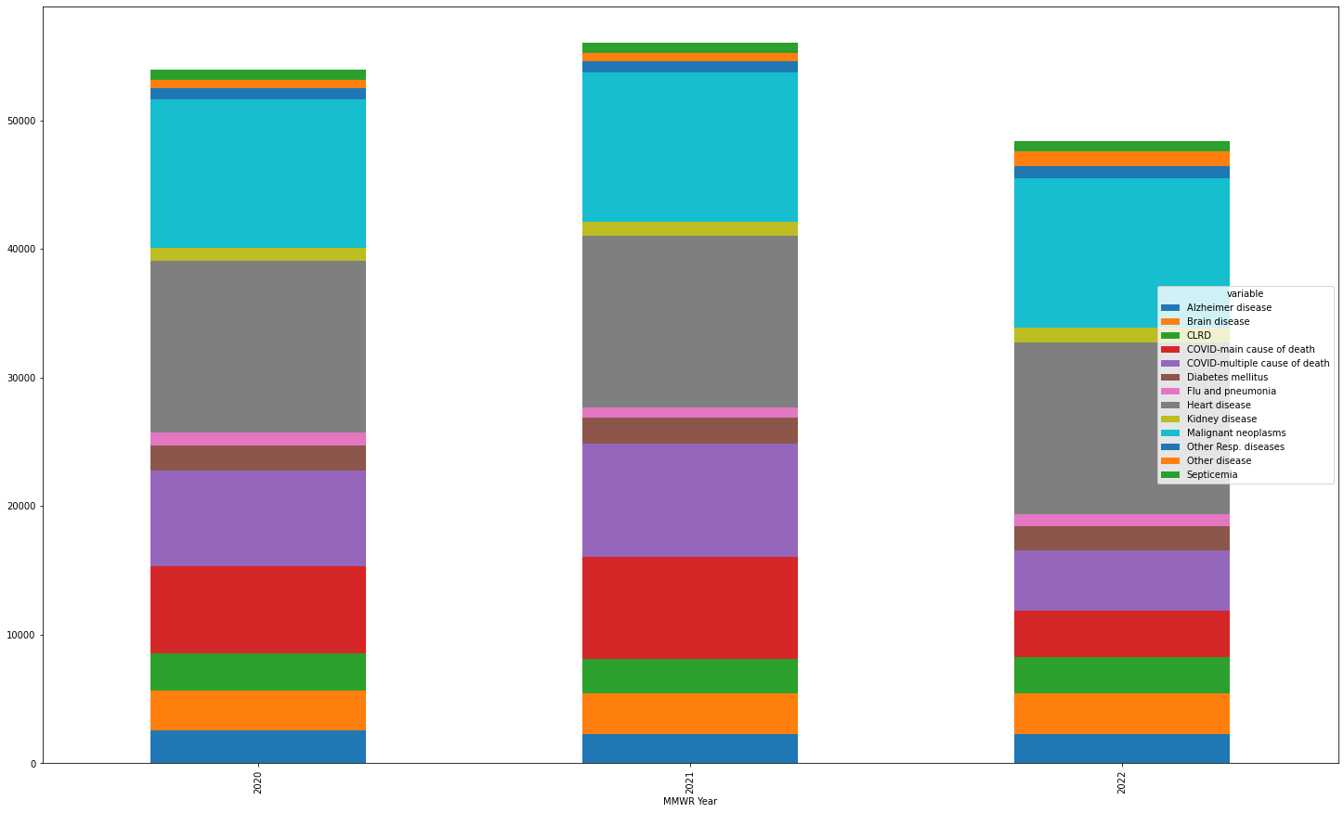

Figure: Weekly average deaths by disease from 2020 to 2022

One thing to note when looking at the quartiles of each disease, COVID related deaths are more spread out compared to others, outliers for COVID related deaths are more pronounced as well. We bring this up because the first two years of the pandemic, there was a lot of uncertainty of how to categorize a person dying because of COVID or another illness.

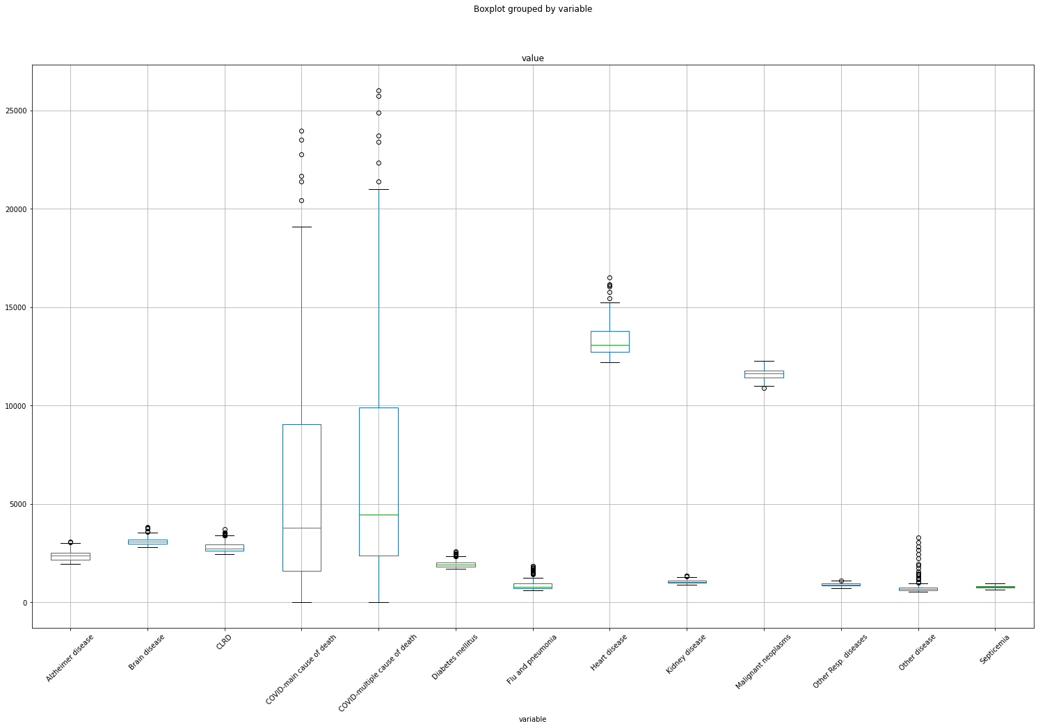

Figure: Box and whisker analysis of weekly death dataset

The figure showing the weekly total number of deaths by diseases in the U.S. in 2020, 2021, 2022 and two months of 2023 is presented below. In counting the total number of deaths, we have ignored the natural cause of death and all causes of death, leaving us with the deaths caused by diseases in the U.S. in 2022. The maximum cases of death across the country were seen in Week 3 i.e., 85,622 and the minimum number of deaths was at 39,862 in Week 6. A glance at the chart shows us the strong indication of seasonality, as the number of deaths increase sharply in the peak winter seasons and slowly dissipates and remains stable in the summer through fall.

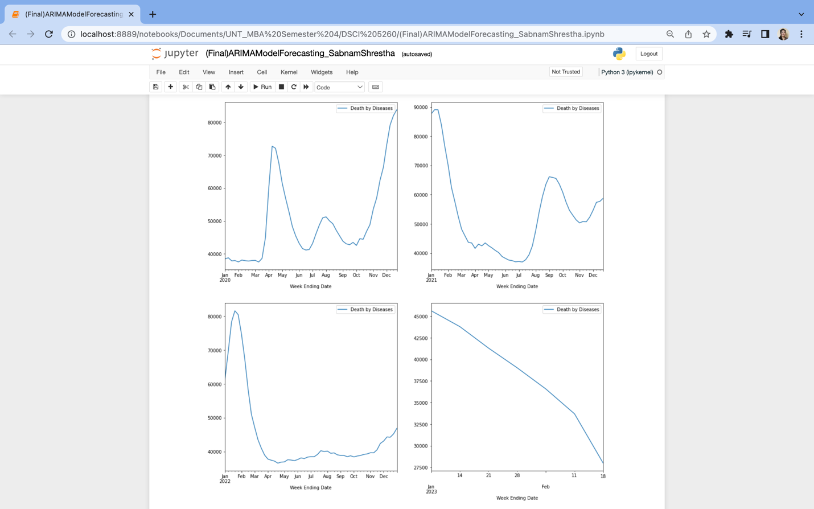

Figure : US Deaths by Diseases across the years 2020-2023(Jan and Feb)

Diseases listed as the causes of death such as influenza and pneumonia, chronic lower respiratory diseases, Covid 19 and other respiratory complications exacerbate during winter months. In further analysis we will look into the data for three years to compare the trends and implement autoregressive integrated moving averages (ARIMA) Model to reduce the impact of any error caused by the occurrence of deaths in prior weeks and provide an accurate prediction of the future trends in deaths by diseases. Using ARIMA model will allow us to deal with both trend and seasonality component and make appropriate decisions about the gravity of the cause of death [31].

Dataset 2: U.S. Census Data – Population by insured versus uninsured.

The second dataset comes from the United States Bureau of the Census for the years 2020 and 2021. Unfortunately, 2023 is not yet available and will not be released until later 2023. The name of the dataset we extracted is entitled ‘S2701: Selected Characteristics of Health Insurance Coverage in the United States’. This dataset on the website contains splits of each state’s population, how many are insured or uninsured, which is broken into different buckets in terms of demographics. We will only select population counts for demographics of interest to make the analysis relevant to our research questions. We are interested in race, education, and employment data:

* White alone
* Black or African American alone
* American Indian and Alaska Native alone
* Asian alone
* Native Hawaiian and Other Pacific Islander alone
* Some other race alone
* Two or more races
* Hispanic or Latino (of any race)
* White alone, not Hispanic or Latino
* Disability
* No Disability
* Less than HS graduate
* HS graduate
* Some college
* Bachelor or higher
* < $25k
* $25k - $49.9k
* $50k - $74.9k
* $75k - $99.9k
* > $100k

These columns are tagged at the end with ‘(Ins.)’ or ‘(Uins.)’, to distinguish which population amounts are insured versus uninsured. Even though the dataset only has 102 records, there are 44 columns that contain many different datapoints for each state and year. We did have to replace a few records under the American Indian, Alaska Native, Native Hawaiian and Pacific Islander columns, where we changed any that had ‘N’ values with 0. This ensured that the columns were truly numeric data types. After data mining and data cleaning was completed, we can look at the number of insured versus uninsured.

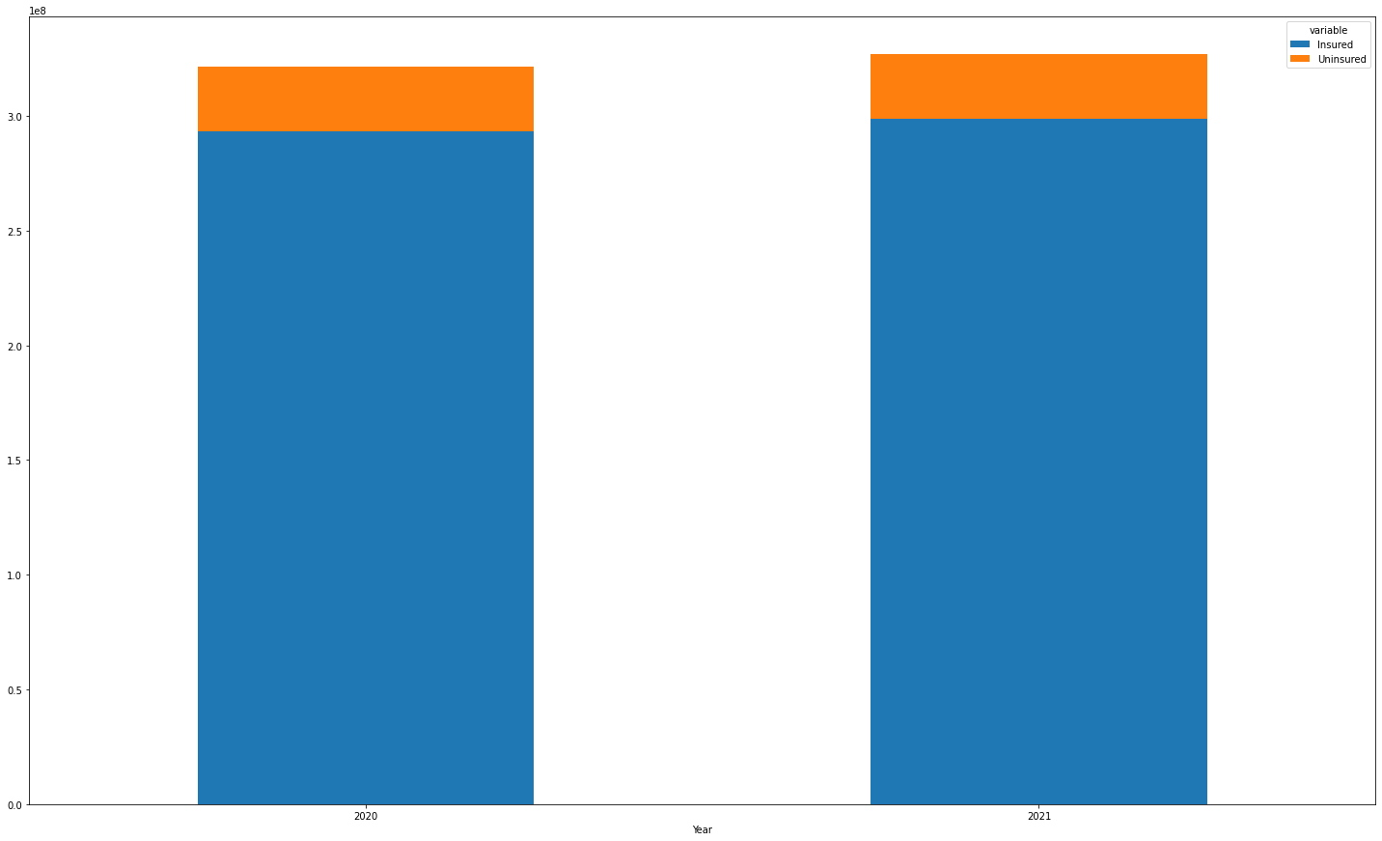

Figure 2: U.S. population grouped by insured versus uninsured for 2020 and 2021

We can see a slight increase in the US population going from 2020 to 2021 but proportionally, the number of uninsured remained the same. This signifies little was done to increase the total quantity of individuals with insurance, which is one of the questions we are trying to solve.

Dataset 3: Uninsured vs. Insured by States

This visualization describes the sum of those insured vs. uninsured by State within the years 2020/2021. Using the dataset: Consensus Insurance Race 2020_2021. Among the abundant factors that could impact insurance, where an individual resides might just be the most important determinant. Although the amount of uninsured is significantly lower, many people lack access to affordable health care to stay healthy. You can also see an influx in insurance throughout some States in 2021 due to the fearmonger of Covid-19 in the previous year. Most citizens realized the importance of insurance, but alternatively some states either equaled out or increased the number citizens that are uninsured.

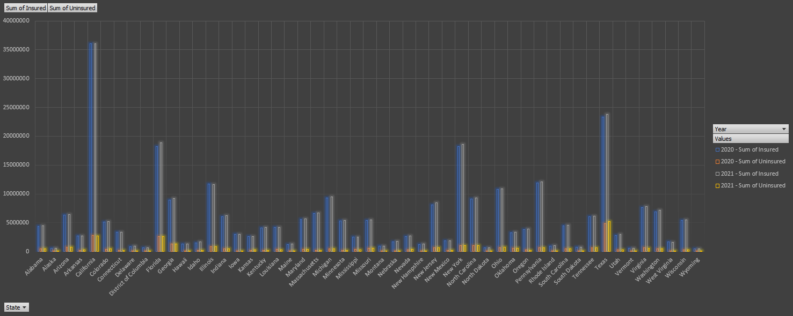

Figure 3: Population of insured versus uninsured by state for 2020 and 2021

# 5. Methodology

## 5.1 Multi-Variable Linear Regression Model

As we mentioned earlier, one of the tools we will use to conduct analysis is multivariable linear regression. This type of regression produces an outcome by using multiple independent inputs from a dataset and determine how strong of a relationship each of those inputs have on the outcome [32]. Multivariable regression is used extensively in different areas of study, not limited to public health research papers. The mathematical formula for linear regression is listed below:

$$y=β_{0}+β_{1}x_{1}+β_{2}x_{2}+…+β_{k}x_{k}+ε$$

When reading this equation, $y$ is referred to as the predicted value of the dependent variable or outcome [33]. In our analysis, this can be thought of as the estimated deaths. The $ε$ part of the model is known as the error term, which can be recalled as the uncertainty not accounted for from the input variables [34]. The last part of the model can be referred to as the linear parameters where $k$ is the quantity of independent variables used. Specific input variables from a dataset are $x_{1}, x_{2}, x_{3}, …, x_{k}$. Again, in our analysis, you can think of the input variables as the number of insured, number of uninsured, total population, etc. $β_{x}$ is the coefficient assigned to each input variable and represents the estimated change in $y$ corresponding to a one-unit change in the assigned variable [33]. There are many ways to have these coefficients calculated without manual work involved. Microsoft Excel has a package that runs through the numbers of the dataset after you have designated what the dependent and independent variables are [35]. SAS has a simple regression function that automatically gives you the parameter coefficients [36]. To understand at a high level how these coefficients are calculated, we can look at the regression model in terms of matrices.

$$Y=Xβ+e$$

$\left[\begin{matrix}y_{1} \\ ⋮ \\ y_{k}\end{matrix}\right]$ = $\left[\begin{matrix}1 & x_{11} & … & x_{mk} \\ ⋮ & ⋮ & ⋮ & ⋮ \\ 1 & x_{1k} & … & x_{mk}\end{matrix}\right]\left[\begin{matrix}β_{1} \\ ⋮ \\ β_{k}\end{matrix}\right]$ + $\left[\begin{matrix}e_{1} \\ ⋮ \\ e_{k}\end{matrix}\right]$

In this form, *k* refers to the quantity of observations from the dataset and *m* is the quantity of independent variables used in the regression model. From here, we can calculate the least squares estimates also in matrix form.

$β= \left[\begin{matrix}β_{1} \\ ⋮ \\ β_{k}\end{matrix}\right]$ = ${(X^{T}X)}^{-1}X^{T}Y$

$X^{T}$ is the transpose of the matrix containing the independent variables while ${(X^{T}X)}^{-1}$ is capturing the inverse of matrix multiplication of $X^{T}$ and $X$ [37].

## 5.2. Autoregressive Integrated Moving Average Model (ARIMA)

Autoregressive integrated moving average models are predictive models used in time series forecasting for non-stationary datasets such as demand, stock prices, spread of diseases and weather conditions [38]. Time series is a sequential measure of data recorded over a regular period [39]. The periodic intervals can represent a variety of granularity of time components in which data was recorded such as daily, weekly, monthly, quarterly, and yearly. The ARIMA models represent a regression model where the dependent variable has a linear function with both dependent variable’s value recorded in the past and error term included such as seasonality factors inherent in temporal datasets.

The ARIMA model for time series forecasting takes the non-stationary data such as the weekly death counts in the U.S. and transforms the predictions in stationary terms incorporating three sophisticated features: differencing order (d), regression order (p) and moving averages order (q) [38]. Thus, by factoring these three orders the ARIMA model will allow us to predict the accurate increase in number of deaths in the US in a stationary format by eliminating the effects total number of weekly deaths in previous weeks and seasonality component that we had observed during peak winter seasons. The three factors, their respective mathematical representation and the merged model components are detailed below:

1. Autoregressive (AR) Model (p):

*ŷt*= c + Φ1*y* t-1 + Φ1*y* t-2 + ….+ Φp*y* t-p + εt

The autoregressive (AR) model is the regression model that predicts the dependent variable as an upright function of the previous lags in the data collected prior time-steps [40]. This is denoted by (p) in the ARIMA(p,d,q) model. This function will help address the effects of death counts recorded in previous weeks. The autoregressive or AR model can eliminate some role of past death counts affecting morbidity count in the present. However, a differing factor is required further to dissolve any such differences.

1. Integrated Differencing (d):

*y* ’t = *y* t – *y* t-1……yt-d = (1 – B)d*y* t

The integrated differencing factor in the ARIMA model is the difference taken to transform the unstable data into static outputs. The differencing factor supports a consistency in the mean, thus eliminating the impact of time trends and seasonal effects [41]. For instance, the maximum death count in the 3rd week of 2022 might soar the average death counts for January in a normal time series analysis but in ARIMA model the integrated differencing eliminates the influence of maximum death count prediction in future for the same month.

1. Moving Average (MA) Model(q):

*ŷt* = c +θ1 εt-1 + θ2 εt-2 + …… + θq εt-q + εt

The moving average model calculates the errors in the past time series by factoring in the unprecedented changes due to unusual events or occurrences. This is denoted by q in the ARIMA(p,d,q) model. For instance, in our exploratory data analysis for the death counts data we observed multiple outliers in the upper extreme due to Covid 19 death counts in 2020 and 2021. Thus, applying moving averages will help address such residuals or errors of the rare occurrence such as a pandemic while predicting total death counts in the future.

**Autoregressive Integrated Moving Average ARIMA(p,d,q) Model:**

*ŷt* = c + Φ1*y’* t-1 + Φ1*y’* t-2 + ….+ Φp*y’* t-p + θ1 εt-1 + θ2 εt-2 + …+ θq εt-q + εt

Finally, by combining the autoregressive (p) model that addresses trend factor in terms of death counts in past week with the moving averages(q) model to eliminate the residual error caused by unusual events such as Covid 19 pandemic by introducing Integrated Differencing (d) to transform non-stationary death count data with different means into a stationary data, we can predict the future death counts that reflects the actual trend in deaths in the U.S. that are caused by the curable and non-curable diseases and hopefully deliver useful insights to improve present healthcare accessibility to bring those numbers down.

## 5.3. Random Forest Regression

Random Forest Regression is a potent regression analysis method that integrates many decision trees to provide a prediction model that is more precise. It works by constructing multiple decision trees using random subsets of the input data and input variables and then considering the average of the predicted values from all the decision trees to create the final prediction.

 Mathematically represented as $$y=f\left(x\right)+ε$$

Where:

* $y$ is the dependent variable, which is the mortality by heart disease value we want to predict.
* $x$ is a vector of independent variables that we use to predict y. Which is age, gender, race, income, education, employment, and access to insurance.
* $f\left(x\right)$ is the predicted value of $y$ (heart disease) based on x(age, gender, race, income, education, employment, and access to insurance).
* $ε$ is the error term, which represents the entropy of $y$.

## 5.5 Support Vector Machine (SVM)

This powerful algorithm addresses classification and linear regression challenges while concurrently identifying outliers for multi-group instances [48]. One aspect of SVM is support vectors, which are described as the datum or point that lies adjacent to a hyperplane; these points are difficult to identify. They are used to determine the most desirable location derived from the group or class with the lowest number of independent characteristics. Support vector machines will be provided to highlight extensive transformations based on the predefined variables listed in an accurate fashion [48]. In layman’s, SVMs magnify the margins around the hyperplane creating a rectangular division to highlight the decision function, identified previously as support vectors.

1. Input: training pairs, such as red and blue shapes.

input features shown as: (x1, x2,..xn) with the output resulting in y.

1. Output: an assemblage of weights indicated as (w1) for each characteristic utilized to predict the value of y mentioned above.

An alternative to a simple SVM is called kernel SVM or the kernel trick. Kernels are utilized in SVMs when an individual needs to transform data that is non-linear and inseparable contrarily to linear and separable, establishing the appropriate partition for outputs [50]. Therefore, considering the following variables: uninsured and insured mortality rate, availability, age, and household income. We will be able to locate interconnections amongst our variables and establish obvious boundaries between those same variables. Subsequently, providing a stronger comprehension of the data and their relationship with mortality.

1. Linear

$f\left(X\right)=w^{T} ⋅ x + b$

The linear kernel will be utilized for text classification since they are linear and distinguishable. In the equation mentioned above, w is simply the weight of a characteristic to be minimized, x is a variable like “household income” to be grouped. Finally, b is simply the relationship between said variables.

1. Polynomial

$f\left(x1, x2\right) = {\left(a +1^{t }⋅x2\right)}^{b}$

The polynomial kernel will be utilized to demonstrate the similarity amongst the variables. Specifically, the similarities between uninsured and insured individuals. The f (x1, x2) represents the boundary to separate our variables. Finally, x1/x2 simply represents our intended data.

1. Sigmoid

$f\left(X, y\right) = \tanh\left(Α⋅X^{T}⋅y+C\right)$

Finally, by incorporating sigmoid kernel we can utilize it interchangeably for linear and non-linear instances. **Alpha** is the weight characteristic, while **C** is provided to consider any misclassification confusion.

## 5.6 Decision trees

We will include a tool known for its decision-making capabilities, a Decision tree. The decision tree will analyze and determine the optimal strategy for any conceivable output of a specific variable depicted as branches. Known as the divide and conquer strategy [49]. Our goal is to demonstrate the characteristics of the sample of mortality and insured rates across states from the following years: 2020, 2021, 2022, and 2023.

For example: we are interested in determining if age has an impact on whether an individual is insured or uninsured using the features listed below.

* Features: Age, Disability, Race, Education, Socioeconomic status.

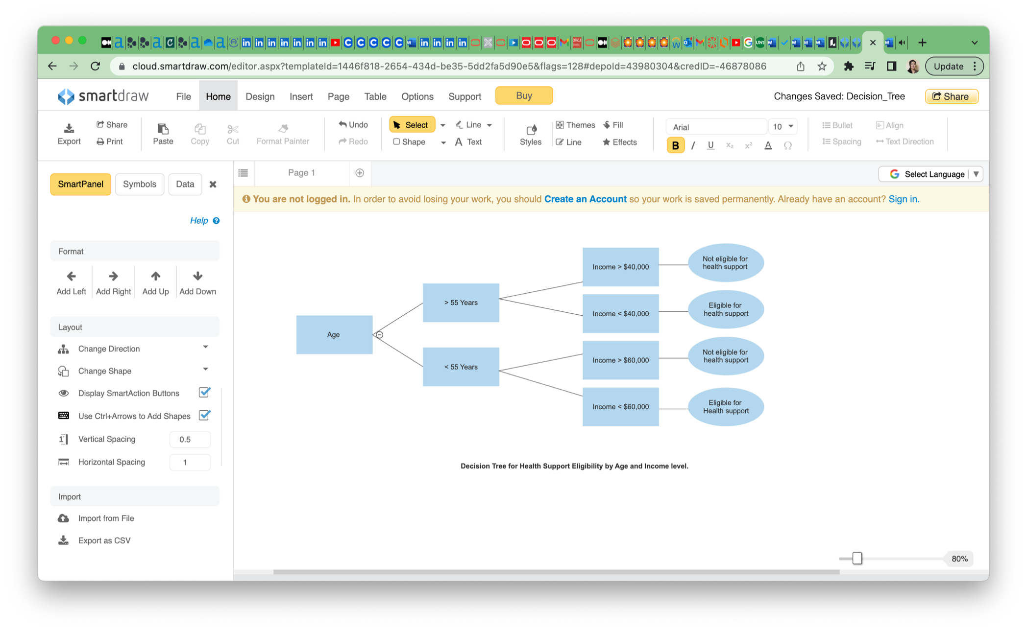

Figure 4: Decision tree model overview

# 6. Results

To ensure our datasets are usable, we appended the weekly death dataset to the U.S. census dataset by joining on columns pertaining to year and state. But before we do this, we must aggregate the deaths to a year level for each cause of death.

## 6.1 Multivariable Linear Regression

As mentioned earlier, we want to look at the different factors that are significant for each cause of death. The first thing we did was normalize the demographic buckets and death counts by each state’s population. This ensured that the varying degrees of population and deaths from each state do not impact the output of the regression. Given the categorical data available pertaining to state information, we utilized a binary encoder to identify the states in a numeric fashion. This resulted in 6 columns: State_0, State_1, State_2, State_3, State_4, and State_5. We used stepwise feature selection to determine the k-best features to use for selection in the regression. When the regression has been completed, we started dropping the features that were not statistically significant.

### 6.1.1 Heart Disease

The 10 independent variables deemed most important was ‘Black or African American alone (Ins.)’, ‘White alone (Uins.)’, ‘Black or African American alone (Uins.)’, ‘Asian alone (Uins.)’, ‘Disability (Uins.)’, ‘HS graduate (Ins.)’, ‘< $25k (Ins.)’, ‘> $100k (Uins.)’, ‘State_1’, ‘State_2’, and ‘State_3’. Below is the plot of standard error for the 20 features entered into the stepwise feature selection. There is a significant jump between the first and second feature and then another jump between the eighth and ninth feature before it starts to bottom out after eleventh feature.

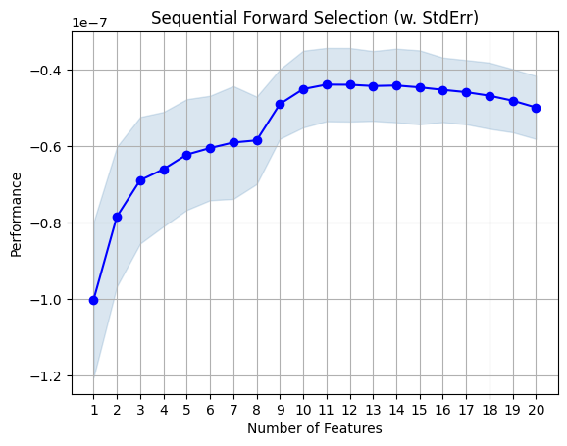

Figure 5: Heart disease stepwise standard error scoring

After a few runs of dropping columns that were not statistically significant and rerunning the regression analysis, we end up with a model with the following independent variables: ‘Black or African American alone (Ins.)’, ‘Disability (Uins.)’, ‘HS graduate (Ins.)’, ‘< $25k (Ins.)’, ‘> $100k (Uins.)’, ‘State_1’ and ‘State_3’. The adjusted r-squared value comes out to 0.795 and regression score (how well the model did, using actual deaths) came out to 0.713. Insured African Americans, uninsured people with a disability and insured high school graduates have a positive effect on deaths caused by heart disease where uninsured individuals with a household income greater than $100k had a negative effect of heart disease deaths. In other words, they seem to be the groups most susceptible to dying from heart disease.

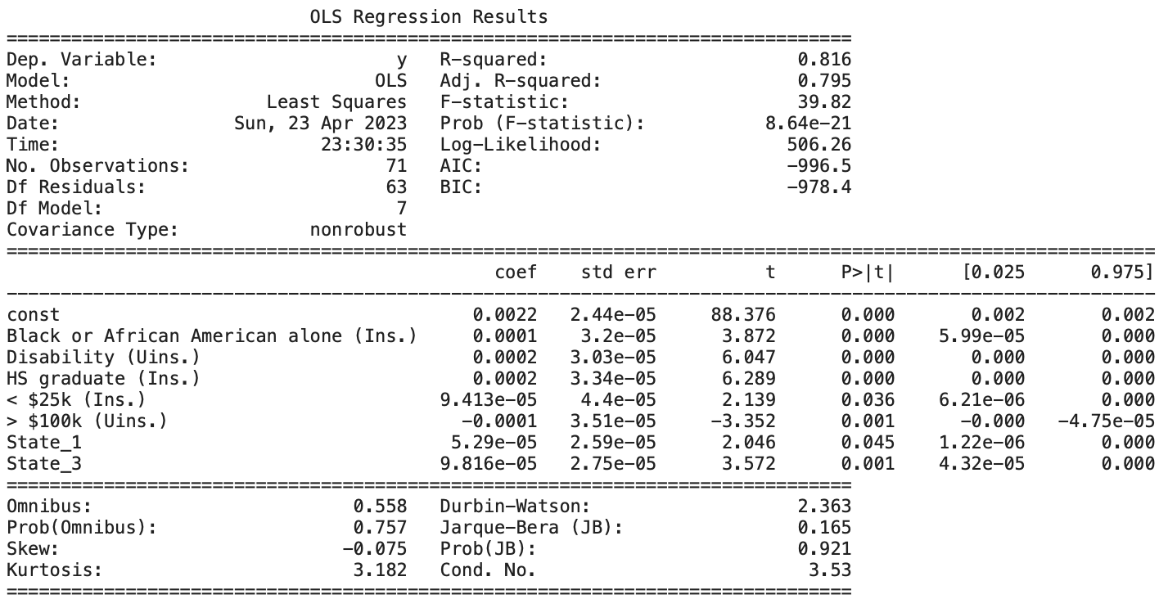

Figure 6: Heart disease regression output

Listed below are two scatter plots for the independent variables, each being grouped by State_1 & and State_3 respectively. It seems that states not in the State_1 have a higher occurrence of heart disease. State_3 looks to have no bearing on heart disease deaths.

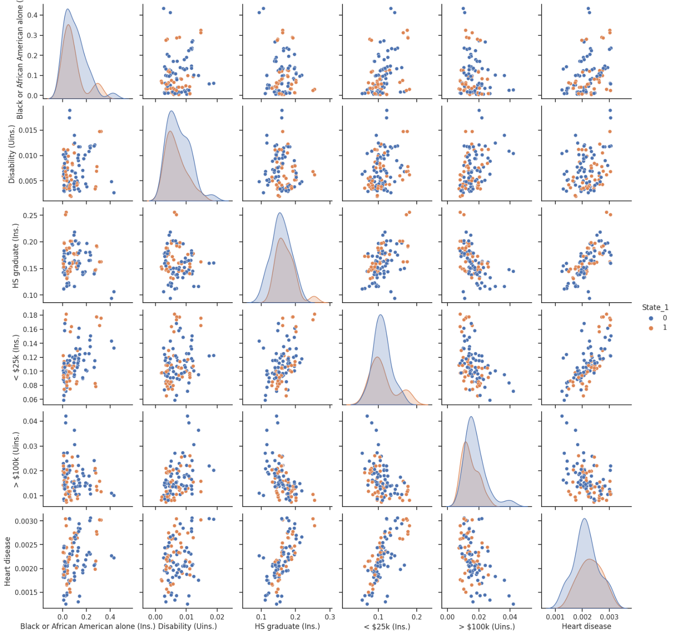

Figure 7: Scatterplot of independent variables where p <0.05, grouped by State_1. Heart disease regression

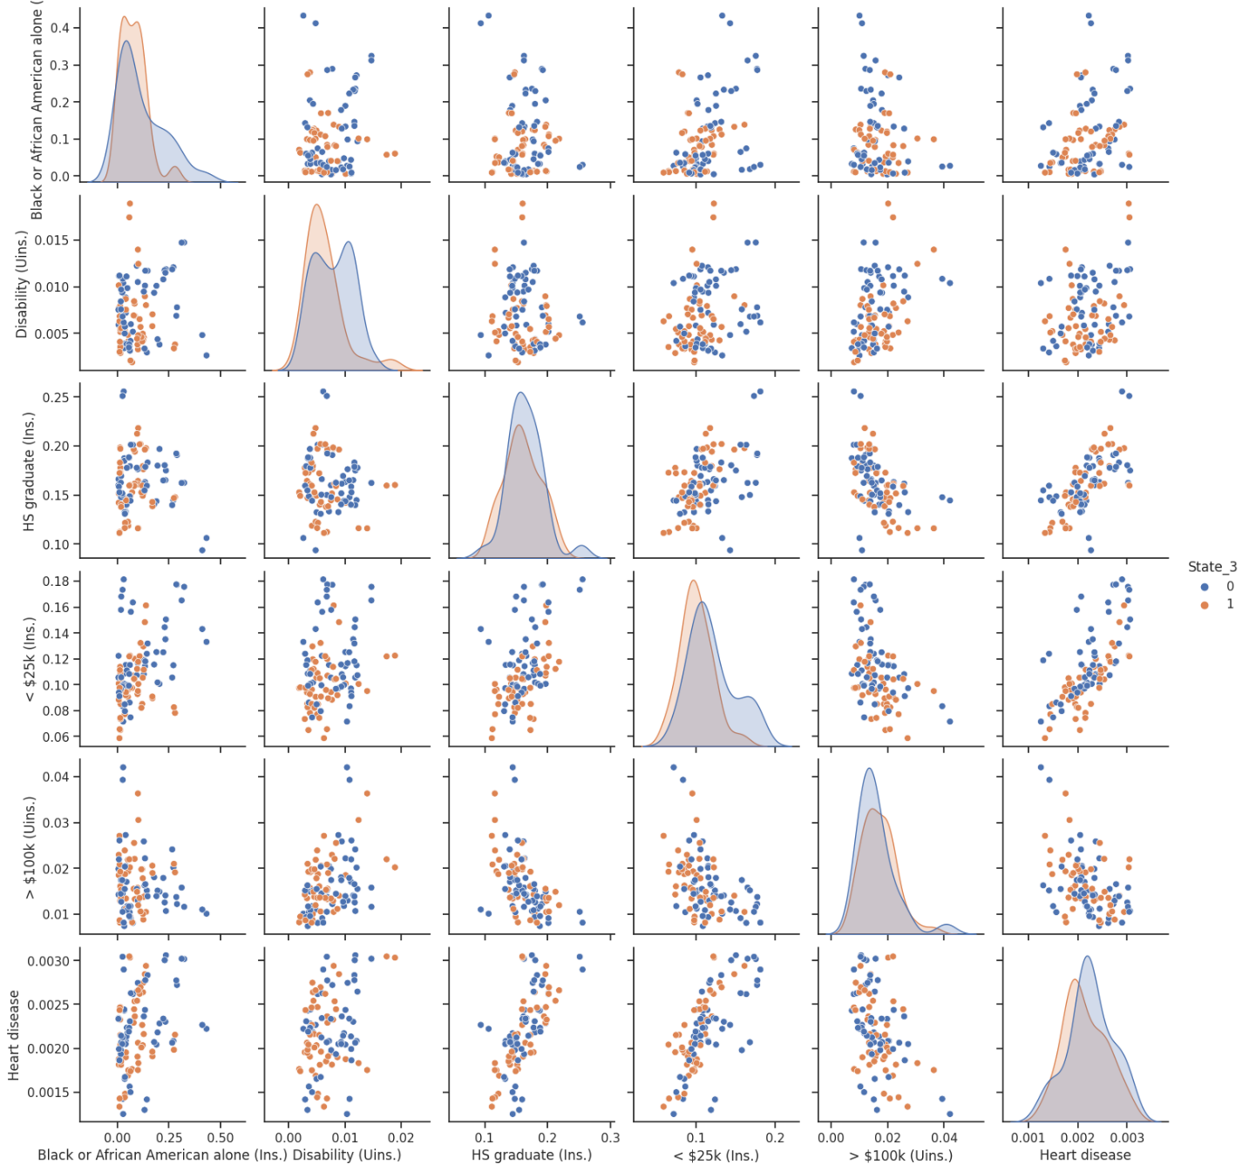

Figure 8: Scatterplot of independent variables where p < 0.05, grouped by State_3. Heart disease regression

### 6.1.2 Malignant neoplasms (cancer)

The stepwise feature selection indicated that there were 12 independent variables deemed most important: ‘American Indian and Alaska Native alone (Ins.)’, ‘American Indian and Alaska Native alone (Uins.)’, ‘Disability (Ins.)’, ‘Disability (Uins.)’, ‘HS graduate (Ins.)’, ‘Some college (Ins.)’, ‘Bachelor or higher (Ins.)’, ‘Some college (Uins.)’, ‘$25k - $49.9k (Ins.)’, ‘> $100k (Uins.)’, ‘State_1’ and ‘State_5’. Below is the plot of standard error for the 20 features entered into the stepwise feature selection.

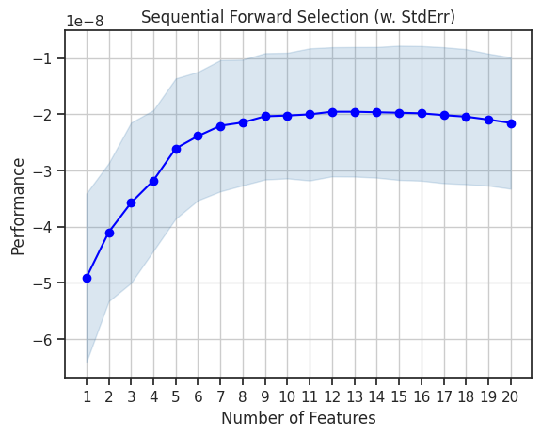

Figure 9: Malignant neoplasms (cancer) stepwise standard error scoring

Following the same process used in heart disease regression analysis, we removed all statistically insignificant independent variables to leave use with the following in the final output for cancer: ‘American Indian and Alaska Native alone (Uins.)’, ‘Disability (Uins.)’, ‘HS graduate (Ins.)’, ‘Some college (Ins.)’, ‘Bachelor or higher (Ins.)’, ‘$25k - $49.9k (Ins.)’ and ‘State_5’. Uninsured individuals with a disability, insured high school graduates, insured bachelor graduates and insured individuals with a household income between $25k and $49.9k had a positive effect of deaths caused by cancer. The final adjusted r-squared value for this model is 0.796 and the regression score of 0.723.

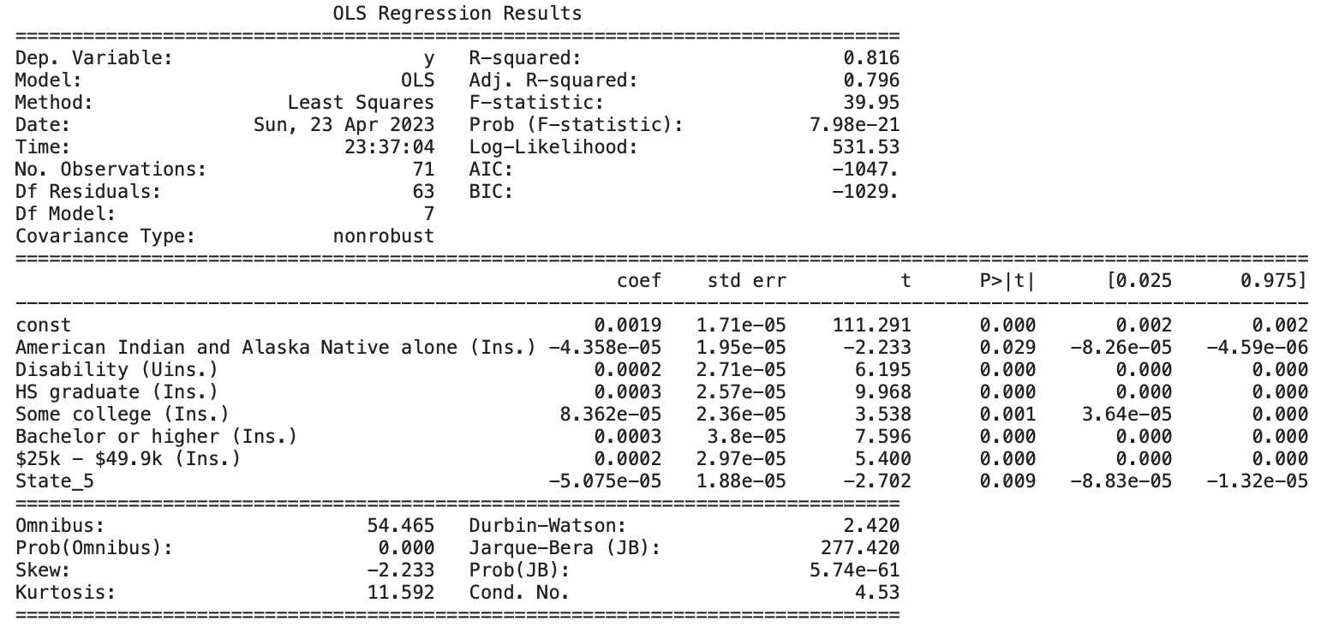

Figure 10: Cancer regression output

Listed below is the scatterplot of the independent and dependent variables, grouped by State_5. Unlike heart disease, the state seems to not have that much bearing on the outcomes of death. In addition, there is only one state feature that is in the final model compared to two in the heart disease model.

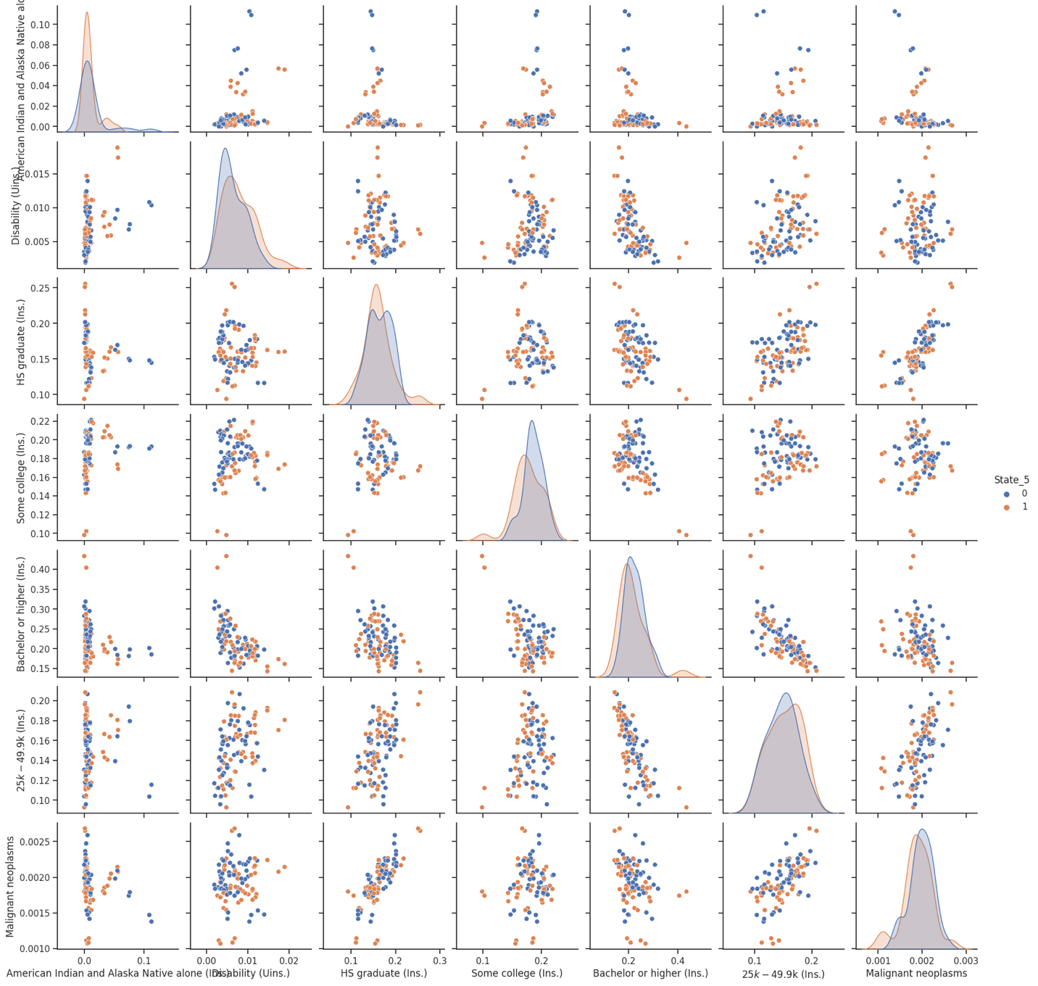

Figure 11: Scatterplot of independent variables where p < 0.05, group by State_5. Cancer regression

### 6.1.3 Diabetes

The independent variables that the stepwise feature selection scored best to use in the regression analysis were the following: ‘Black or African American alone (Uins.)’, ‘American Indian or Alaska Native alone (Uins.)’, ‘Some other race alone (Uins.)’, ‘Disability (Ins.)’, ‘Disability (Uins.)’, ‘Bachelor or higher (Ins.)’, ‘Some college (Uins.)’, ‘$25k - $49.9k (Ins.)’, ‘> $100k (Ins.)’ and ‘State_2’. Below is the graph of standard error scoring for 20 features used.

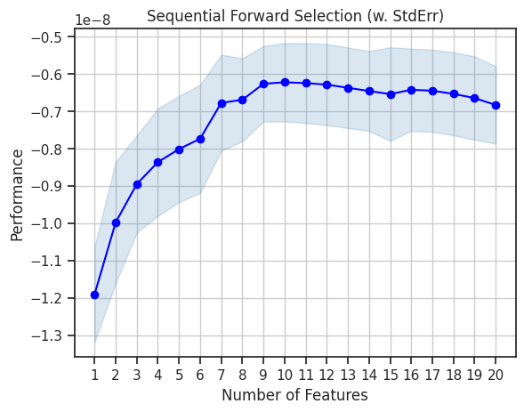

Figure 12: Diabetes stepwise standard error scoring

The final regression output for diabetes yielded an adjusted r-square score of 0.693 and a regression score of 0.497, which is the lowest of all three for both scores. Individuals that were uninsured living with a disability, insured individuals in a household income between $25k and $49.9k along with insured individuals earning more than $100k had the highest coefficients in the regression. Unlike the previous two models, there is no state related feature in the final output of the model.

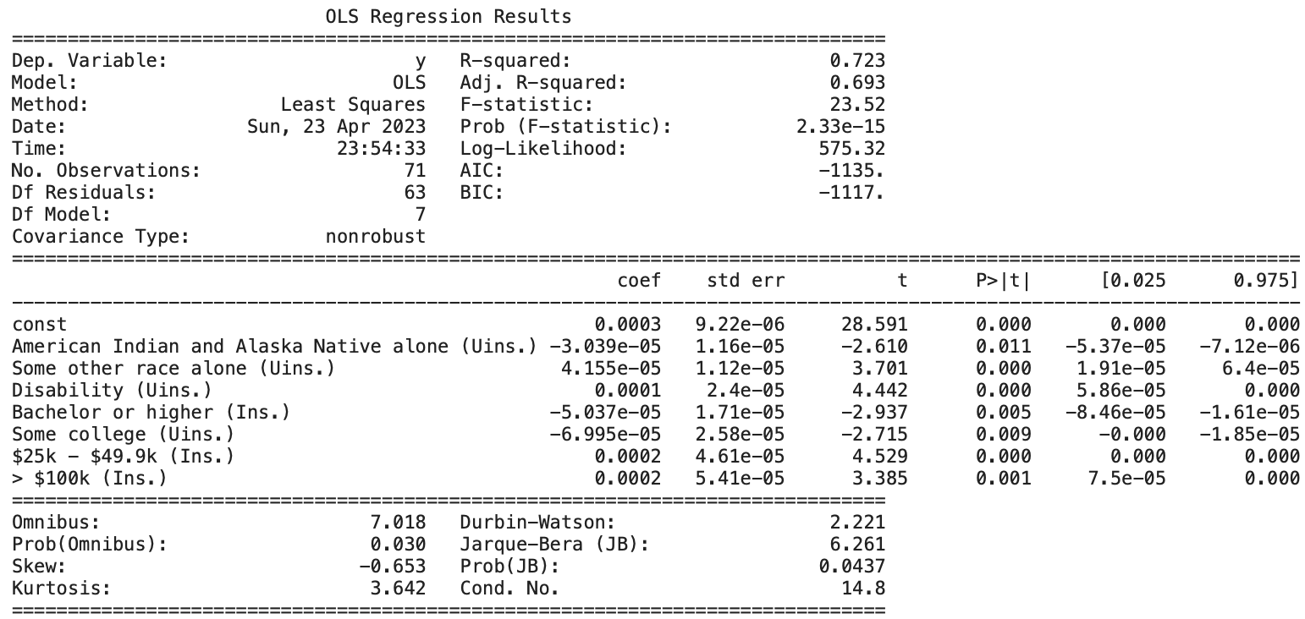

Figure 13: Diabetes regression output

Listed below is the scatter plot for diabetes independent and dependent variables. The plot between diabetes and uninsured with disability does have a few outliers and is not as uniformly trending positively compared to individuals between $25k and $49.9k.

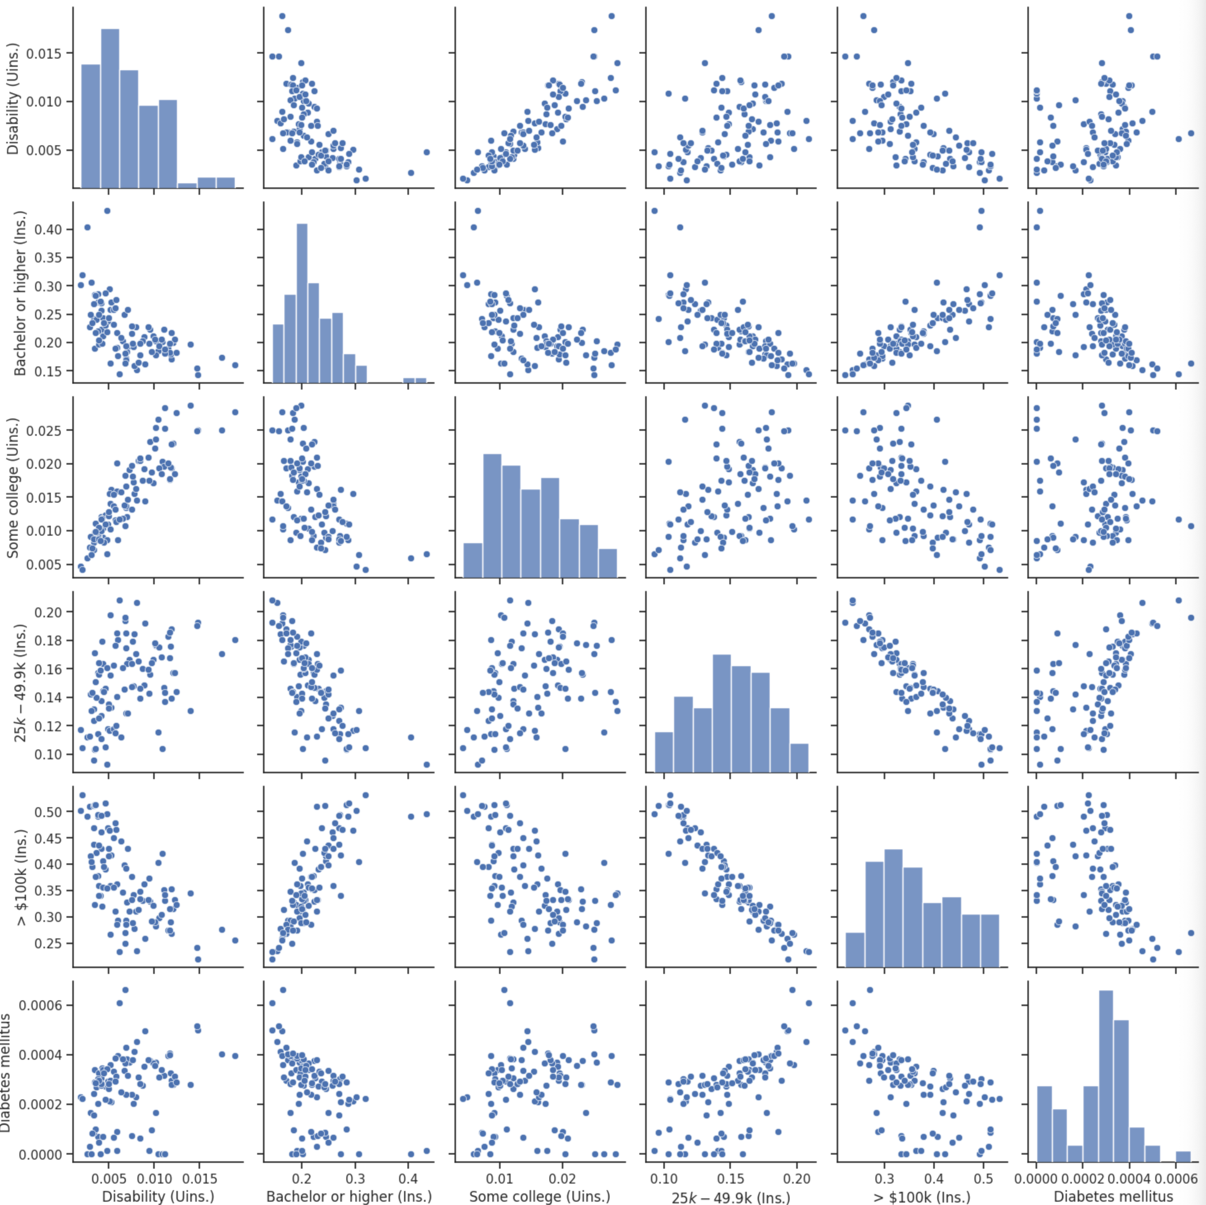

Figure 14: Scatterplot of independent variables where p < 0.05. Diabetes regression

## 6.2 Autoregressive Integrated Moving Average Model (ARIMA)

A key component in our analysis is dealing with spatiotemporal aspect of the datasets. The first dataset with the observations of weekly death count across U.S. can be used to forecast the deaths in the future related to diseases, allowing further insights into the type and size of targeted insurance coverage plan aimed to reduce the number of deaths from such diseases. Thus, to conduct a time-series analysis, we specifically look into the first dataset and perform the necessary data transformation to run ARIMA Model.

Since, the Weekly provisional deaths by state and select diseases dataset has several causes of death listed including, natural, non-natural and diseases, we have tried to restrict our analysis to the deaths caused by diseases, to be able to find and prescribe solutions for targeted insurance coverage only. Thus, a separate data frame containing just the required information i.e., Week ending date, Jurisdiction of Occurrence, and all the select diseases are used. Further, all the deaths by select diseases are combined in a single column to see the cumulative impact of diseases in U.S. Mortality.

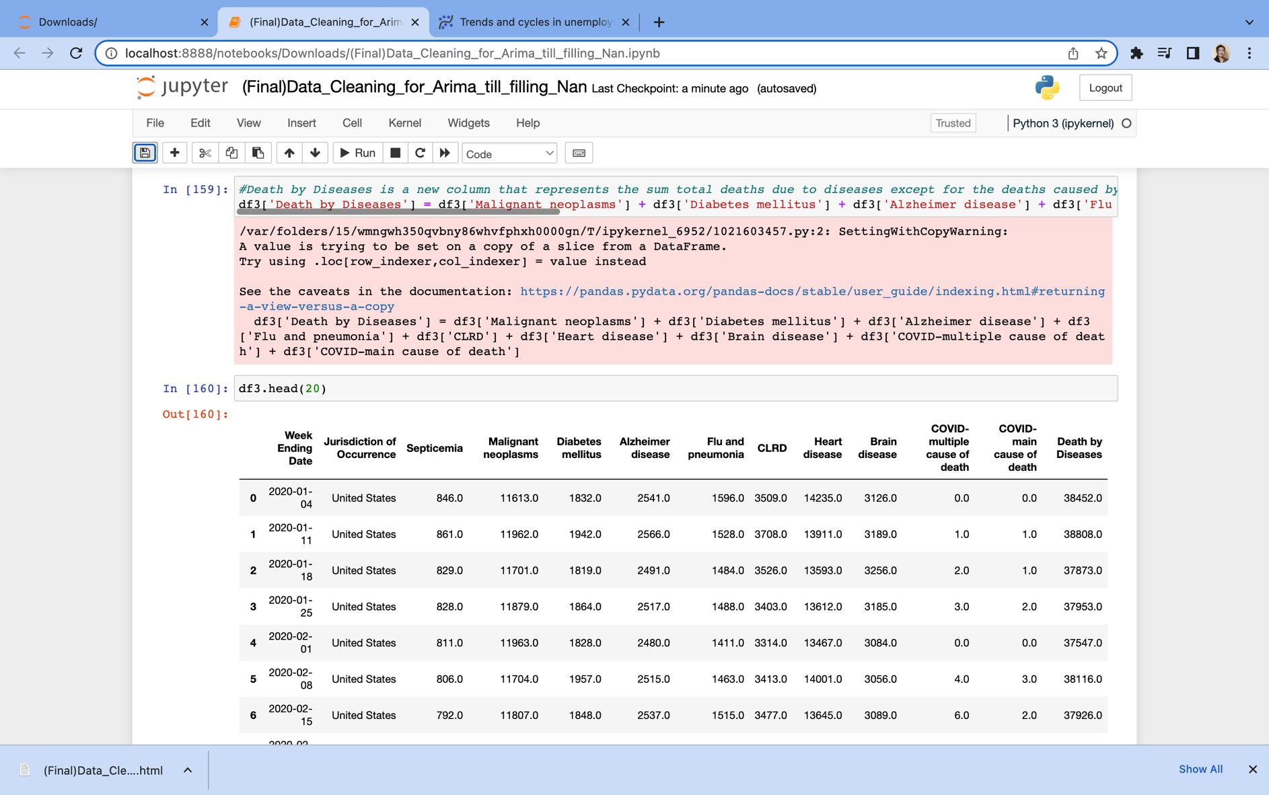

Figure : This code represents the new combined column called “Death by Diseases” which essentially combines all of the deaths by select diseases in the Weekly provisional death count dataset.

We have made sure that all null values were converted to zero to allow the summation of number of death counts across diseases columns into a single “Death by Disease” column. Further, setting the date as an index we looked at the deaths in United States caused by leading diseases such as Malignant Neoplasms, Diabetes, Heart Disease, CLRD and Alzheimer diseases combined in a singled column for the years 2020, 2021, 2022 and two months in 2023 we get a plot that is shown below. Since, the compact nature of the chart doesn’t provide us a complete picture of overall trend, we further created subplots to see if there is any seasonality depicted in the death count by diseases. A following set of subplots representing single year for the four years shows that for 2021 and 2022, January through April, depicts a peak of death count caused by select diseases.

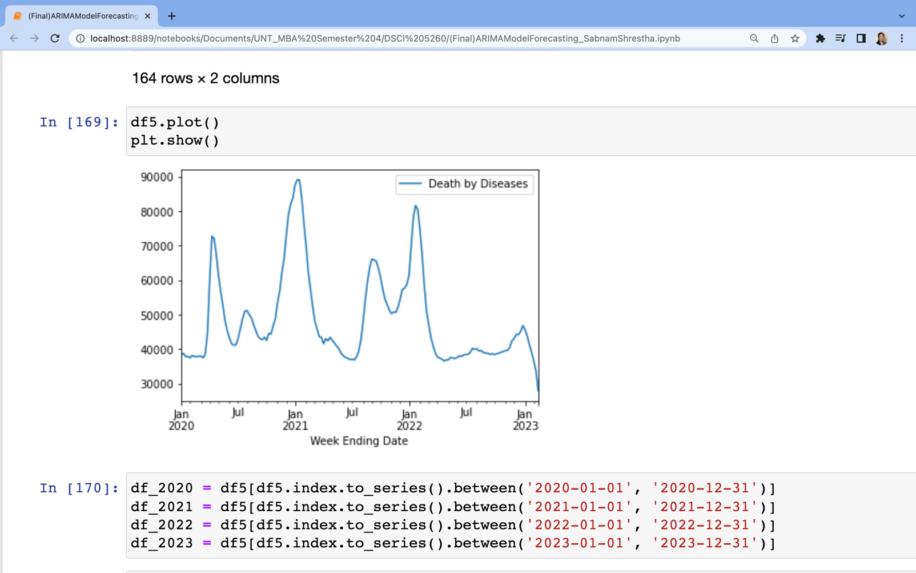

Figure : The line chart that depicts Deaths by combined diseases in the United States in 2020, 2021, 2022 and January and February months of 2023.

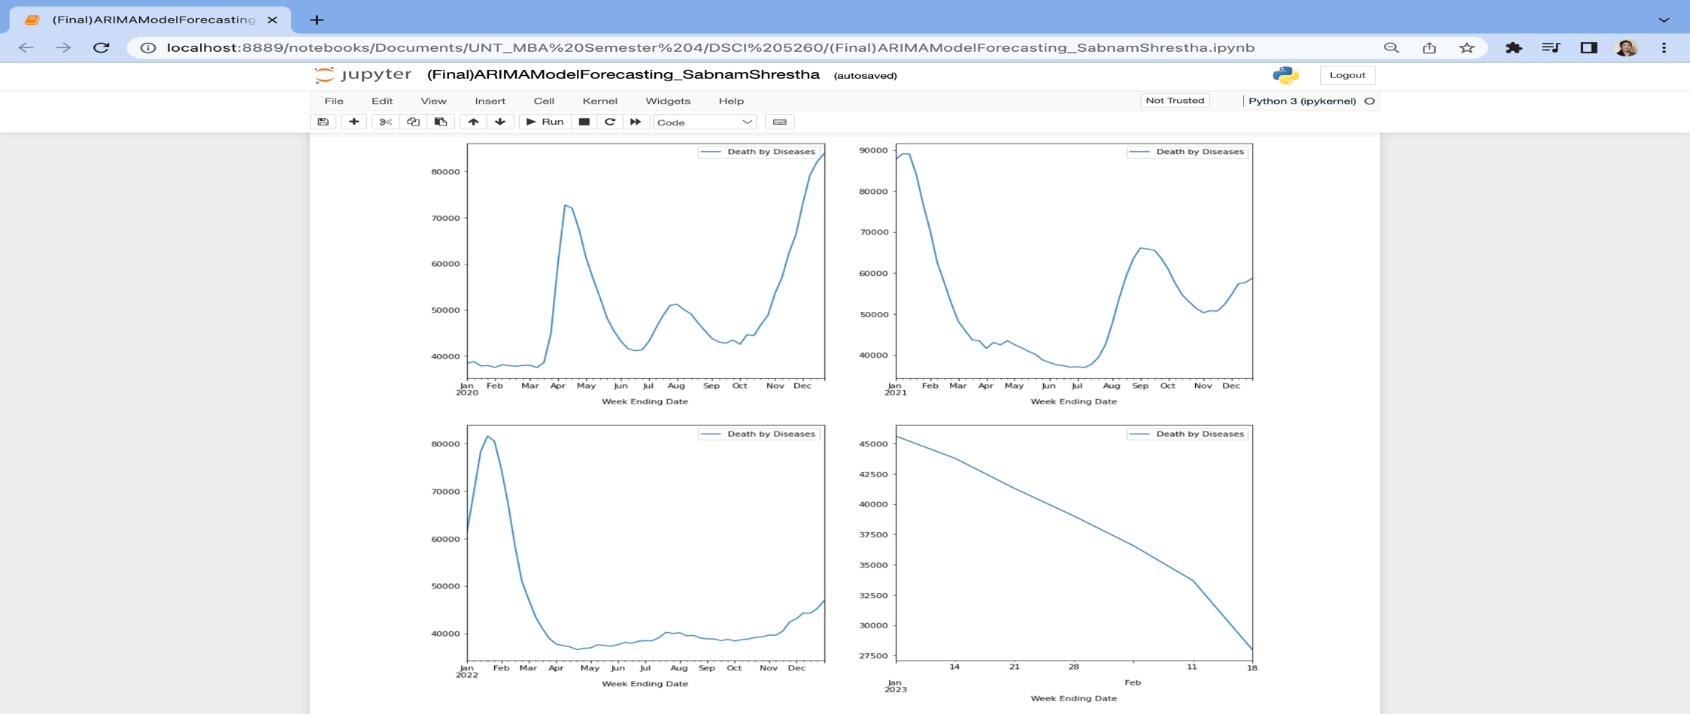

Figure : : The subplots separating the death by diseases visuals for every single year, including partial data for 2023.

Next, we take a logarithmic function of the original data to standardize the visual for large and small observations across several year. This provided us with a solid basis to run the Autoregressive Integrated Moving Average model as the seasonality component in the dataset becomes more obvious after plotting the chart in a logarithmic scale.

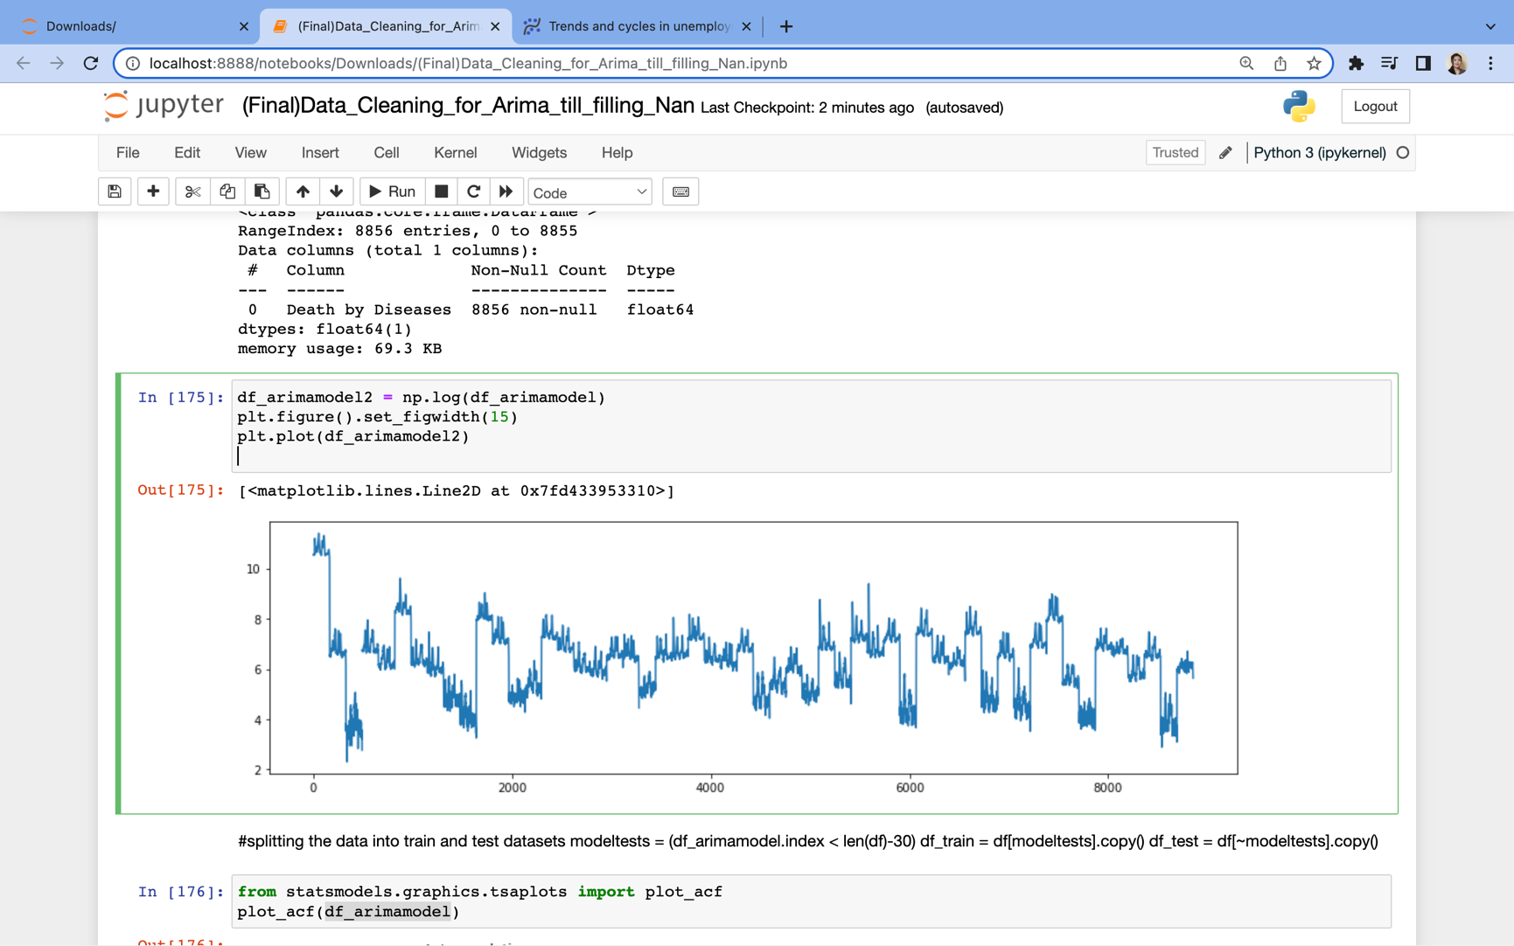

Figure : Death Counts by Diseases over the four years plotted in a logarithmic scale.

### 6.2.1 The Autocorrelation Function:

Apart from the seasonality aspect, the time series data can require separate analyses depending on whether the data is stationary or non-stationary. The understanding of stationarity of data is important to gain a perspective on the mean, variance, and autocorrelation to further select a model that can accurately predict the future trends. A linear relationship measured in terms of lags in every new data value can be provided in an Autocorrelation Function (ACF). Likewise, a new data acquired can be sufficiently used to predict a data in the past by removing the lower order lag for a stationary data using a Partial-Autocorrelation Function (PACF).

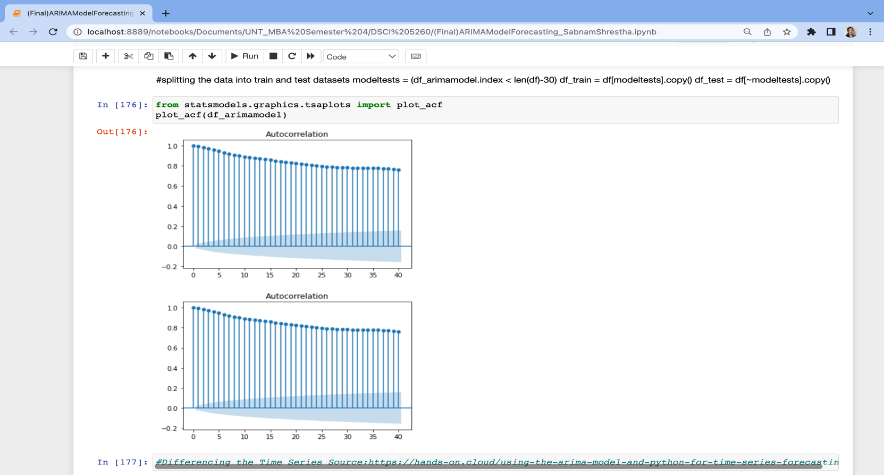

Figure: ACF plot representing high lags slowly declining with incremental data.

The ACF plot shows that our data is non-stationary and a model apt for non-stationary data is needed to accurately predict the time series. Thus, we continue with ARIMA model as it deals with non-stationary data and we proceed with fitting our ARIMA model to see if we can make accurate prediction of number of deaths caused by leading diseases in the U.S.

### 6.2.2 Determining the Parameters for ARIMA Model.

The three key components of an ARIMA model are the parameters p, d and q represented as Autoregression (p) that is a function of lags in the data, Integrated differencing factor (d) that transforms the non-stationary data into stationary data and the Moving Average (q) that calculates the errors in the past data. In our case, we use the data for 2020, 2021 and 2022 to fit the model using a df_arimamodel_train function. In the first iteration we used a p,d and q of (1, 1, 2). Given, a continuous weekly data, we used a p of 1, and an integrated differencing factor of 1 and a q of 2 for adjusting seasonality errors in the death counts.

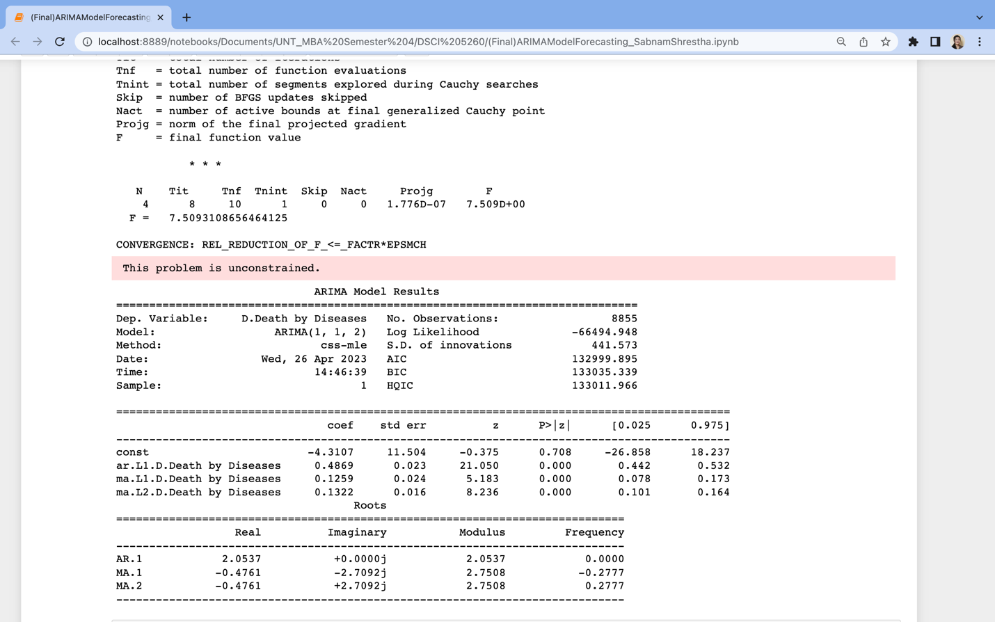

Figure : The First Iteration of the ARIMA model with a (p,d,q) of (1,1,2)

After, the first iteration we see that the errors are fairly high. Thus, we re-run ARIMA model using a (p, d, q) with values (1, 2, 2) and see how that changes the estimates of errors.

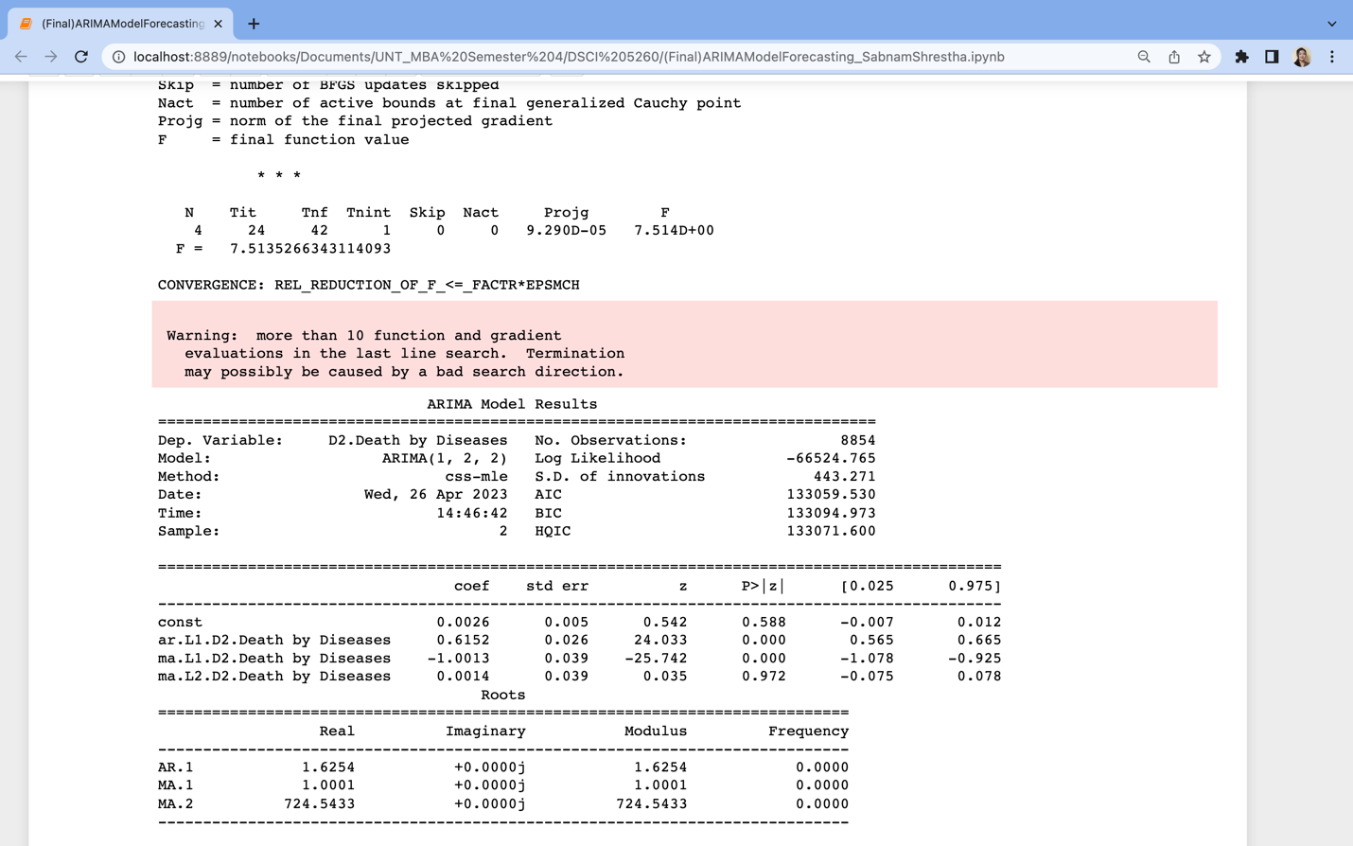

Figure : Second Iteration of ARIMA model with (p,d,q) of (1,2,2).

The second iteration of the ARIMA model has a low error estimation across all the three parameters. This gives us the confidence that our model sufficiently predicts the number of deaths by diseases based on the weekly death counts. This is also represented in a graph that shows a side-by-side comparison of the actual and forecasted data as shown below.

Figure : The ARIMA model Forecasted vs Actual Death by Diseases Comparison Plot

## 6.3. Random Forest Regression:

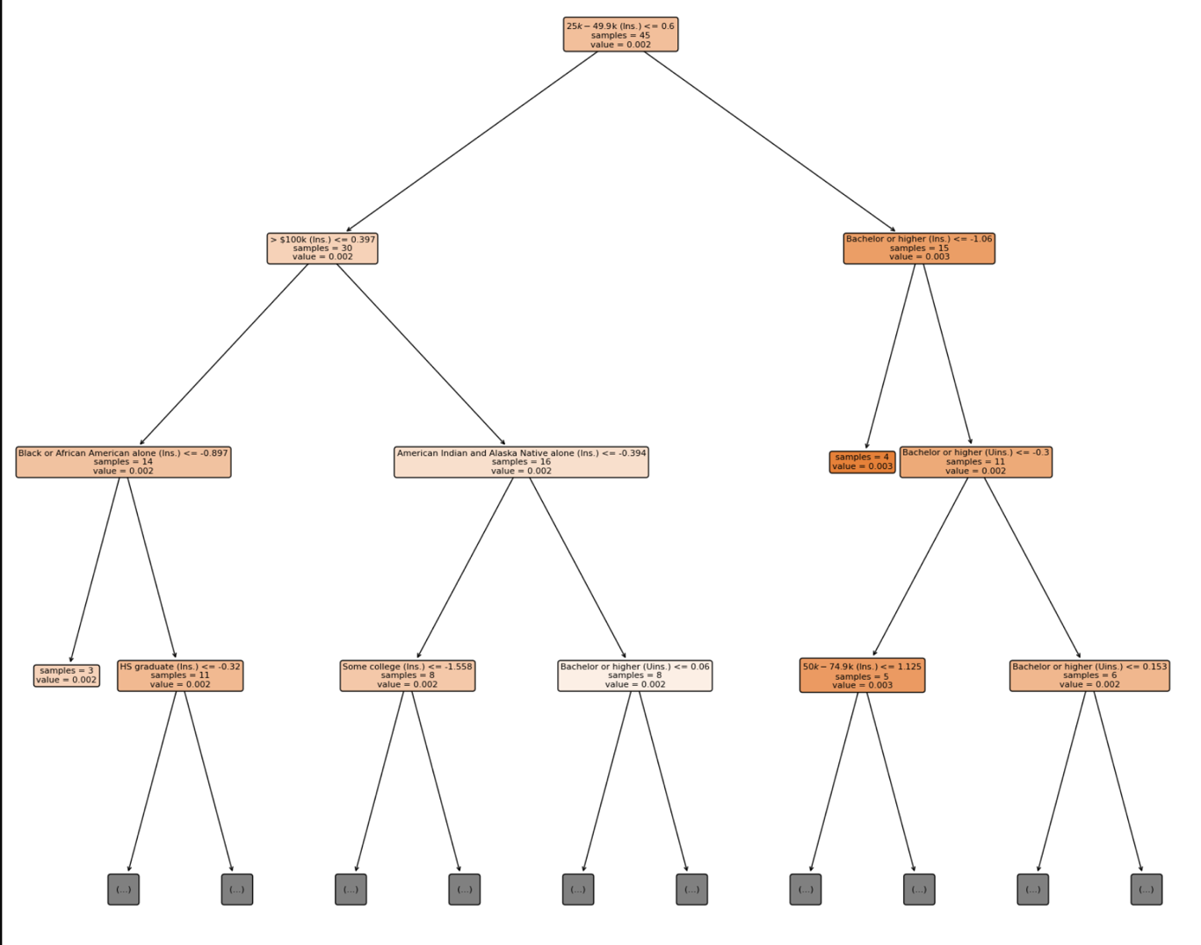

Figure Random Forest Regression: Decision Tree Plot

Random forest regression is fitted on merged data (Weekly death dataset to the U.S. Census dataset by join on columns pertaining to year and state). The maximum amount of depth for the tree was set to 4. The minimum number of samples required to split the internal node is 5. The number of the decision tree in the random forest is specified as 500. The most important feature for predicting death by heart disease is income, which is used to split the tree at the first level. Individuals with income between 25k to 49.9k are more likely to have a higher risk of death by heart disease. In the second split, the left branch represents individuals with income more than the 100k, the second split was performed using the "race" feature where the model predicted that individuals of African American (insured) descent have a higher probability of death by heart disease compared to individuals of other races. While the right branch of the second split, has individuals who are American Indian and Native who are insured had the higher probability of death by heart disease compared to individuals of other races. The third split was performed by the education features where in the branch (African American insured) individuals who are high school graduates or less had the probability of death by heart disease. While on the right side of the split (American Indian and Native) individuals insured with some college degree or less and individuals with bachelor’s degree or less education(uninsured) was more likely to be affected.

While the right branch from the first split, represents the education information, who are either did bachelors or higher education. The model predicts that individuals with less than a high school education have a higher probability of death by heart disease compared to those with a high school education or higher.

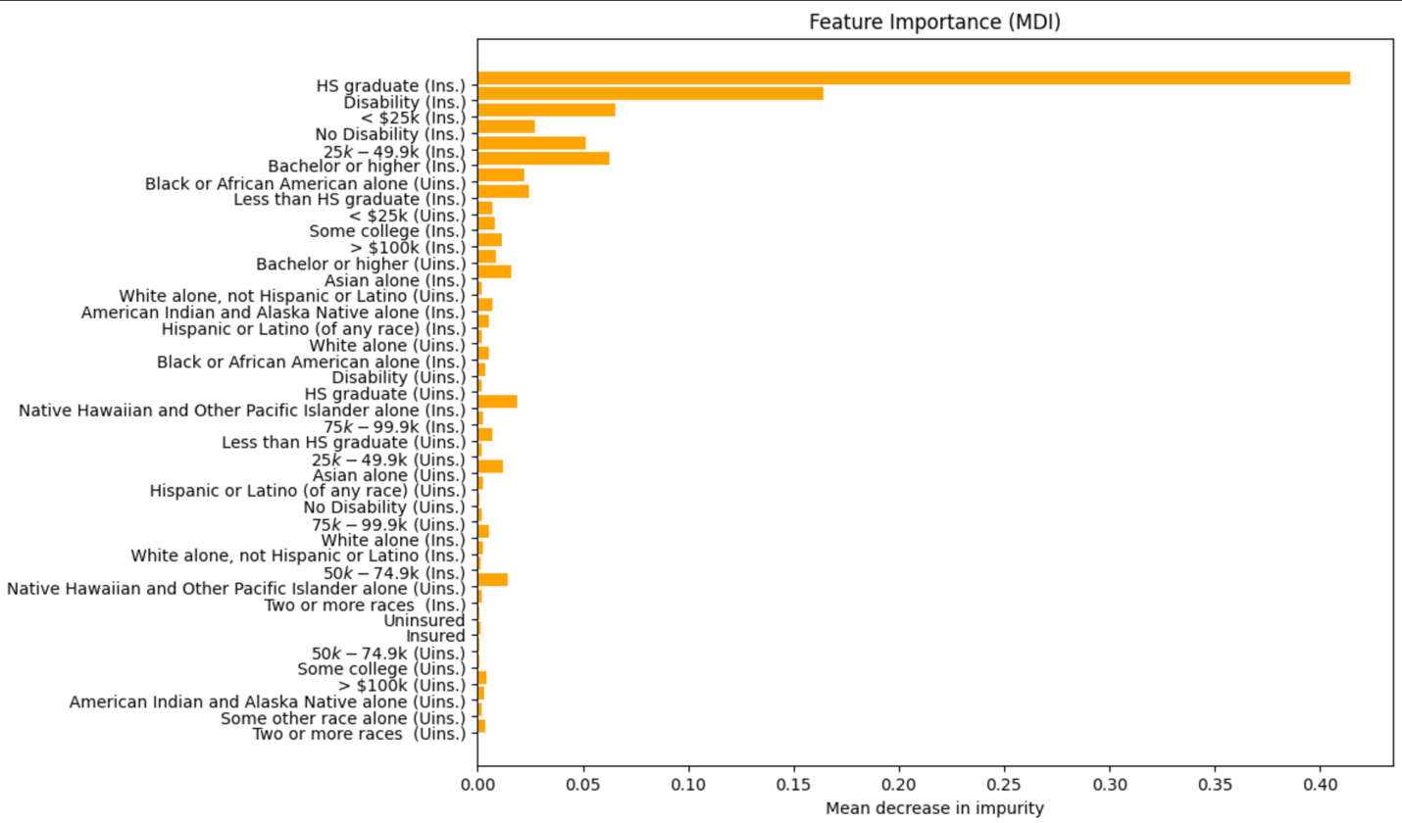

Figure Random Forest Regression- Bar plot with Permutation Function

After fitting the pipeline with training data, the code calculates the permutation importance of each feature on the test data. The permutation function shuffles the values of each feature one by one and calculates the decrease in model performance. The difference between the original model performance and the performance with shuffled feature values represents the feature importance score. In the above graph, the x-axis represents the mean decrease in impurity (MDI), the y-axis represents the feature name, and the yellow bar represents the percentage of the total MDI that can be assigned to each feature displayed in the bar for that feature. The graph reveals that the top five features that have the strongest association with high mortality rates are individuals who are high school graduates with insurance, insured individuals with disabilities, individuals with an annual income below $25,000, insured individuals without disabilities, and individuals with an annual income between $25,000 to $49,900. Usually, individuals who have insurance tend to have a low mortality rate.

## 6.4. Support Vector Machine:

We chose to utilize Support Vector Machine because of its ability to address classification and linear regression challenges. To build the support vector model, we had decided on the vector classifier object which must be done by running a linear kernel. The linear kernel allows to estimate how accurate the classifier is at predicting the rate of the uninsured by State. We ultimately received a classification rate of 66.9%, which is considered average. For further evaluation we aimed to check for regression, known as the coefficient of determination. We received a value of R2.

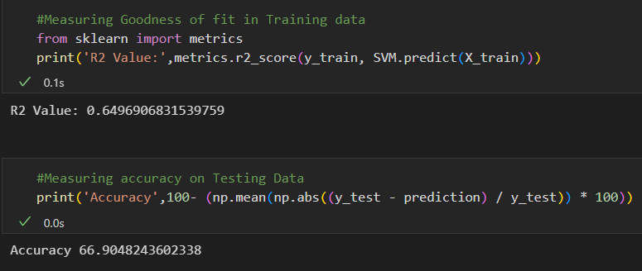

Figure : SVM Scoring

## 6.5. Decision Tree:

As mentioned, we wanted to apply a method known for analyzing plausible outcomes to demonstrate a series of choices; determines the optimal strategy for a specific variable. The learning algorithm is called a Decision Tree. The illustration below is based on the “Census Insurance Race 2020_2021” dataset. Which contains a class-conscious, tree like structure, that consists of a single root node, internal nodes, and leaf nodes. The maximum depth or length of the longest path from the tree was set to 6. The minimum number of decisions was set to 5 to depict a wider range of outcomes. Lastly, the number of trees taken into consideration was set at 500 to provide better performance. Immediately we can recognize that individuals without a disability have a higher likelihood of being uninsured. The prominent variable or node was then split into two internal nodes: Disability (once more) and Insured. Insured has hire probability, so the model predicted that individuals that were indeed insured were at least HS graduates and made between 50k -74.9k annually.

The model indicates that individuals with less than a high school education have a higher probability of being uninsured in the United States.

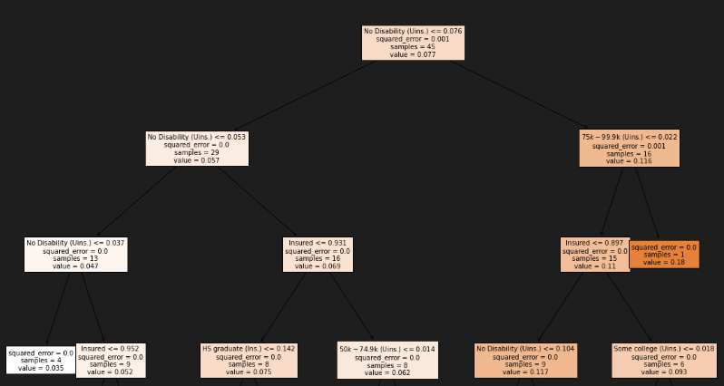

Figure : Decision Tree of Uninsured

# 7. Conclusions

## 7.1 Research Issues and Recommendations

Due to the nature of the dataset, we chose for this research paper, we believe the results compiled would have performed better with a larger volume of data and columns that worked better in classifier models. For that reason, we were not able to perform geospatial analysis and instead did random forest regression to look at the demographics leading to heart disease death.

## 7.2 Linear Regression

When looking at the regression outputs for heart disease, cancer, and diabetes, they all had uninsured individuals with disabilities as a common independent variable that was statistically significant. Although a bit obvious, it does make sense that this group of individuals would appear in all three models since they are a very vulnerable group. This just reiterates the importance of having medical coverage to help facilitate the cost of treatment and visits related to these diseases, making sure that medical care is easily accessible for all, no matter what health condition someone has.

One thing we were expecting to see was the importance that location or state played in the regression. Only the heart disease and cancer models had state information in the final output as statistically significant but nowhere close to having the level of effect as other independent variables. This finding might lend to the idea that, although not analyzed in this model, the causes of these deaths are a nationwide issue instead of a specific statewide issue. This could also mean any attempt to improve the health of the U.S. population must start from the top, i.e., nationwide legislature and health programs.

In terms of the adjusted r-square score, the heart disease and cancer regression models scored 0.795 and 0.796 respectfully while the diabetes model score at 0.693. This seems to indicate that either there was not enough data available, or the columns provided in the model were not good enough compared in the heart disease or cancer models. The r2_score of the diabetes model further iterates this assumption with a score of 0.497 compared to heart disease (0.713) and cancer (0.723).

Given that we were only able to use only two years, this may have affected the effectiveness of each of the regression models. As mentioned previously, when running any of the analysis in this paper, we only had 102 observations to build models. Our assumption is that if we were able to gather more data containing weekly deaths and census for the same years, our models may have been better at distinguishing the causes of death, especially the regression models.

A possible future area to explore and analyze is the population of people with disability in the United States with hopefully more data pertaining to visits, medication, accessibility to care and quality of visits. It would be interesting and helpful to discover why they continue to be uninsured when there are programs such as Medicaid and Medicare that could potentially provide the services and treatment needed to help with their ailments. But also discover if there are any roadblocks to accessing these resources.

## 7.3 Autoregressive Integrated Moving Average Model (ARIMA)

Our primary motivation behind choosing the Weekly provisional death count across the United States was to assist the institutions that formulate healthcare coverage plans at a national level. Since, longitudinal data used in prior studies were not effective in predicting the need for the interventions, institutions were struggling to plan and budget these coverages. Using the weekly continuous data for three years 2020, 2021 and 2022 and fitting an ARIMA model has allowed us to prepare, understand and forecast the trends for future by factoring in the lags in previous data points, seasonality, and other errors inherently present in a non-stationary data. The model also allowed us to set the parameters commensurate to our data and provided with a comparison basis for the actual and predicted forecasts for death by diseases only. This further provides an insight for targeted efforts in battling these diseases, prioritizing spending for coverage for the leading diseases such as Heart Disease, Diabetes, Malignant Neoplasms, CLRD, Brain Disease, Flu & Pneumonia and Septicemia while sufficiently reducing the outlier effects created by Covid deaths.

## 7.4 Random Forest Regression:

According to the random forest regression analysis, both results indicate that people with insurance are more likely to die from heart disease, which contradicts the common assumption that having insurance means a lower mortality rate.

The bar plot and decision tree outputs indicate individuals with lower education (High school graduates) have fewer job opportunities, leading to lower wages having higher mortality rates. Similarly, the decision tree identifies the income bracket of 25k-49.9k(ins), which suggests a group with limited access to healthcare has higher mortality rates.

These results suggest that policymakers should pay closer attention to this section of individuals with limited education and job opportunities. Improving access to education and providing job training could help these individuals secure higher-paying jobs. This would reduce their chance of heart disease and other health issues by making sure they concentrate on having healthy food and avoiding financial stress. Moreover, everyone should have access to quality healthcare and a healthy lifestyle, regardless of their income or education level.

## 7.5. Support Vector Machine

We expected to be able to display a model with ease, but SVM had its own plan. Support Vector Machine was unsuitable for large datasets with large numbers. It’s unable to create a margin of separation between the variables to be classified. Moreover, our dataset made it nearly impossible to create an indicator if someone was insured or uninsured. Finally, the coefficient of determination of linear regression was extremely high, which showcased its inaccuracies.

## 7.6. Decision Tree

Due to our dataset, we were unable to create an accurate Decision Tree. The dataset lacked the data necessary to answer, ‘yes’ or ‘no’ questions within the first node. Our Decision tree lacked representations of logical functions, which allows for alternatives instances to occur. As a result, the tree was convoluted.

# 8. References

|  |  |
| --- | --- |
| [1] | M. McCough, I. Telesford, S. Rakshit, E. Wager, K. Amin and C. Cox, "How does health spending in the U.S. compare to other countries?," 09 02 2023. [Online]. Available: https://www.healthsystemtracker.org/chart-collection/health-spending-u-s-compare-countries/. |
| [2] | R. Tikkanen and M. K. Abrams, "U.S. Health Care from a Global Perspective, 2019: Higher Spending, Worse Outcomes?," 30 January 2020. [Online]. Available: https://www.commonwealthfund.org/publications/issue-briefs/2020/jan/us-health-care-global-perspective-2019. |
| [3] | E. R. Berchick, J. C. Barnett and R. D. Upton, Health insurance coverage in the United States, 2018, US Department of Commerce, US Census Bureau, 2019. |
| [4] | B. D. Sommers, A. A. Gawande and K. Baicker, "Health insurance coverage and health—what the recent evidence tells us," *N Engl J Med,* vol. 377, no. 6, pp. 596 - 593, 2017. |
| [5] | S. Woolhandler and D. U. Himmelstein, "The relationship of health insurance and mortality: is lack of insurance deadly?," *Annals of Internal Medicine,* vol. 167, no. 6, pp. 424 - 431, 2017. |
| [6] | G. Pappas, S. Queen, W. Hadden and G. Fisher, "The increasing disparity in mortality between socioeconomic groups in the United States, 1960 and 1986," *New England journal of medicine,* vol. 329, no. 2, pp. 103 - 109, 1993. |
| [7] | G. Gong, S. G. Phillips, C. Hudson, D. Curti and B. U. Philips, "Higher US rural mortality rates linked to socioeconomic status, physician shortages, and lack of health insurance," *Health Affairs,* vol. 38, no. 12, pp. 2003 - 2010, 2019. |
| [8] | L. Pilote, K. Dasgupta, V. Guru, K. H. Humphries, J. McGrath, C. Norris, D. Rabi, J. Tremblay, A. Alamian, T. Barnett and others, "A comprehensive view of sex-specific issues related to cardiovascular disease," *Cmaj,* vol. 176, no. 6, pp. S1 - S44, 2007. |
| [9] | R. H. Brook, J. E. Ware Jr, W. H. Rogers, E. B. Keeler, A. R. Davies, C. A. Donald, G. A. Goldberg, K. N. Lohr, P. C. Masthay and J. P. Newhouse, "Does free care improve adults' health? Results from a randomized controlled trial," *New England Journal of Medicine,* vol. 309, no. 23, pp. 1426 - 1434, 1983. |
| [10] | M. C. Garcia, M. Faul, G. Massetti, C. C. Thomas, Y. Hong, U. E. Baur and M. F. Iademarco, "Reducing potentially excess deaths from the five leading causes of death in the rural United States," *MMWR Surveillance Summaries,* vol. 66, no. 2, p. 1, 2017. |
| [11] | P. Leung and A. Mas, "Employment effects of the affordable care act medicaid expansions," *Industrial Relations: A Journal of Economy and Society,* vol. 57, no. 2, pp. 206 - 234, 2018. |
| [12] | National Advisory Committe on Rural Health and Human Services, "Mortality and life expectancy in rural America: connecting the health and human service safety nets to improve health outcomes over the life course," National Advisory Committee on Rural Health and Human Services Rockville, MD, 2015. |
| [13] | H.-J. Kim, M. P. Fay, E. J. Feuer and D. N. Midthune, "Permutation tests for joinpoint regression with applications to cancer rates," *Statistics in medicine,* vol. 19, no. 3, pp. 335 - 351, 2000. |
| [14] | E. Moy, M. C. Garcia, B. Bastian, L. M. Rossen, D. D. Ingram, M. Faul, G. M. Massetti, C. C. Thomas, Y. Hong, P. W. Yoon and others, "Leading causes of death in nonmetropolitan and metropolitan areas—United States, 1999--2014," *MMWR Surveillance Summaries,* vol. 66, no. 1, p. 1, 2017. |
| [15] | CDC, "Center for Disease Control and Prevention," 2019. [Online]. Available: https://www.cdc.gov/nchs/hus/sources-definitions/nhis.htm. |
| [16] | K. Dasgupta, V. Guru, K. H. Humphries, J. McGrath, C. Norris, D. Rabi, J. Tremblay, A. Alamian, T. Barnett, J. Cox, W. A. Ghali, S. Grace, P. Hamet, T. Ho and S. Kirkland, "A comprehensive view of sex-specific issues related to cardiovascular disease," *Canadian Medical Association Journal,* vol. 176, no. 6, 2007. |
| [17] | T. J. G. R. M. T. John R. Petrie, "Diabetes, Hypertension, and Cardiovascular Disease: Clinical Insights and Vascular Mechanisms," *Canadian Journal of Cardiology,* vol. 34, no. 5, pp. 575-584, 2018. |
| [18] | T. A, V.-E. J and K. R. , "Forgone Medical Care Associated With Increased Health Care Costs Among the U.S. Heart Failure Population.," *Journal of the American College of Cardiology,* vol. 9, no. 10, pp. 710-719, 2021. |
| [19] | P. Y. J. L. S. Parikh, "The Impact of Financial Barriers on Access to Care, Quality of Care, and Vascular Morbidity Among Patients with Diabetes and Coronary Heart Disease," *Journal of General Internal Medicine,* vol. 29, pp. 76-81, 2014. |
| [20] | W. J. S. E. G. J. Z. A. Ayanian JZ, "Unmet Health Needs of Uninsured Adults in the United States.," *The Journal of the American Medical Association,* vol. 284, no. 16, pp. 2061-2069, 2000. |
| [21] | J. N. B. E. B. D. Sorlie PD, "Mortality in the Uninsured Compared With That in Persons With Public and Private Health Insurance.," *Archives of Internal Medicine,* vol. 154, no. 21, pp. 2409-2416, 1194. |
| [22] | A. C.-S. G. G. Fowler-Brown, "Risk of Cardiovascular Events and Death—Does Insurance Matter?," *Journal of General Internal Medicine,* vol. 22, no. 4, pp. 502-507, 2007. |
| [23] | B. D. P. a. J. C. S. Carmen DeNavas-Walt, "Income, Poverty, and Health Insurance Coverage in the United States: 2010," 01 September 2010. [Online]. Available: https://www.census.gov/library/publications/2011/demo/p60-239.html. |
| [24] | W. S. L. K. M. D. B. D. H. D. Wilper AP, "A national study of chronic disease prevalence and access to care in uninsured U.S. adults," *Annals of Internal Medicine,* vol. 149, no. 3, pp. 170-176, 2008. |
| [25] | M. M. D. R. H. R. a. S. R. C. Cathy Schoen, "Affordable Care Act reforms could reduce the number of underinsured US adults by 70 percent," *Health Affairs,* vol. 30, no. 9, pp. 1762-71, 2011. |
| [26] | B. A. N. A. G. J. S. C. K. D. Y. R. G. P. Khatana SAM, "Association of Medicaid Expansion With Cardiovascular Mortality," *JAMA Cardiology,* vol. 4, no. 7, pp. 671-679, 2019. |
| [27] | P. H. Thomas MaCurdy, "Implications of Time Series Models for Long Term Projections of Heakth Expenditures," *Medicare & Medicaid Research Review,* 2013. |
| [28] | P. N. M. B. A. D. P. K. F. B. N. F. M. M. M. B. ,. e. a. Kyle J Foreman, "Forecasting life expectancy, years of life lost, and all-cause and cause-specific mortality for 250 causes of death: reference and alternative scenarios for 2016–40 for 195 countries and territories," *The Lancet,* vol. 392, no. 10159, pp. 2052-2090, 2018. |
| [29] | Y. N. A. G. J. N. W. ,. Alina Baciu, Communities in Action: Pathways to Health Equity., Washington : National Academies Press (US), 2017. |
| [30] | Office of the Actuary, "CMS.GOV," United States Government, 15 Dec 2021. [Online]. Available: https://www.cms.gov/newsroom/press-releases/national-health-spending-2020-increases-due-impact-covid-19-pandemic. [Accessed 22 03 2023]. |
| [31] | D. O. B. M. R. D. Z. P. J. S. Tatiana Petukhova, "Assessment of autoregressive integrated moving average (ARIMA), generalized linear autoregressive moving average (GLARMA), and random forest (RF) time series regression models for predicting influenza A virus frequency in swine in Ontario, Canada," *National Library of Medicine's National Center for Biotechnology Information,* vol. 13 , no. 6, 2018. |
| [32] | B. Hidalgo and M. Goodman, "Multivariate or multivariable regression?," *American journal of public health,* vol. 103, no. 1, pp. 39 - 40, 2013. |
| [33] | B. L. Bowerman, R. T. O'Connell and A. B. Koehler, "The Linear Regression Model," in *Forecasting, Time Series, and Regression*, United States of America, Brooks/Cole, 2005. |
| [34] | A. Gallo, "A Refresher on Regression Analysis," 04 11 2005. [Online]. Available: https://hbr.org/2015/11/a-refresher-on-regression-analysis. [Accessed 2023]. |
| [35] | A. C. Cameron, "EXCEL 2007: Multiple Regression," [Online]. Available: https://cameron.econ.ucdavis.edu/excel/ex61multipleregression.html. [Accessed 21 03 2023]. |
| [36] | SAS Institute Inc, "The REG Procedure," 13 12 2019. [Online]. Available: https://documentation.sas.com/doc/en/pgmsascdc/9.4_3.4/statug/statug_reg_gettingstarted02.htm. [Accessed 21 03 2023]. |
| [37] | The Pennsylvania State University, "5.4 - A Matrix Formulation of the Multiple Regression Model," 2018. [Online]. Available: https://online.stat.psu.edu/stat462/node/132/. [Accessed 21 03 2023]. |
| [38] | N. Bora, "Capital One Tech," Capital One, 2021. [Online]. Available: https://www.capitalone.com/tech/machine-learning/understanding-arima-models/. [Accessed 26 03 2023]. |
| [39] | S. Prabhakaran, "Machine Learning Plus," Machine Learning Plus, 22 08 2021. [Online]. Available: https://www.machinelearningplus.com/time-series/arima-model-time-series-forecasting-python/. [Accessed 26 03 2023]. |
| [40] | A. Kumar, "vitaflux.com Data Analytics," 23 08 2022. [Online]. Available: https://vitalflux.com/different-types-of-time-series-forecasting-models/. [Accessed 26 03 2023]. |
| [41] | R. Rasheed, "Towardsdatascience," 11 July 2020. [Online]. Available: https://towardsdatascience.com/why-does-stationarity-matter-in-time-series-analysis-e2fb7be74454#:~:text=When%20forecasting%20or%20predicting%20the,do%20not%20change%20over%20time.. [Accessed 26 03 2023]. |
| [42] | Institute of Medicine (US) Committee on Health Insurance Status and its Consequences, "Summary of Findings and Recommendation," in *America's Uninsured Crisis: Consequences for Health and Health Care*, Washington (DC), National Academis Press (US), 2009. |
| [43] | J. Michael McWilliams, "Health consequences of uninsurance among adults in the United States: recent evidence and implications," *The Milbank Quarterly,* vol. 87, no. 2, pp. 433 - 494, 2009. |
| [44] | H. Rosen, F. Saleh, S. Lipsitz, S. O. Rogers and A. A. Gawande, "Downwardly mobile: the accidental cost of being uninsured," *Archives of surgery,* no. 11, pp. 1006 - 1011, 2009. |
| [45] | A. R. C. E. A. Cohen, "health Insurance Coverage: Early Release of Estimates From the National Health Interview Survey, January - June 2022," p. 21, 2022. |
| [46] | S. P. D. C. Jill Bernstein, "How does insurance coverage improve health outcomes," *Timely Information from Mathematica,* pp. 1-5, 2010. |
| [47] | C. Shetty, "TowardsDataScience," 22 09 2022. [Online]. Available: https://towardsdatascience.com/time-series-models-d9266f8ac7b0. [Accessed 26 03 2023]. |
| [48] | V. I. R. Berwick, "An Idiot's guide to Support vector machines (SVMs)," 2013. |
| [49] | D. Roth, "Decision Trees," Pennsyvania, 2016. |
| [50] | B. Stecanella, "Support Vector Machines (SVM)," 22 June 2017. |

# 9. Authors’ Contributions

|  |  |  |
| --- | --- | --- |
| **Task** | **Task Description** | **Author** |
| Visual 1, 2 & 4 | Data | Carlos Gomez |
| 5.5: Support Vector Mach.  5.6: Decision tree  Dataset 3: Uninsured vs. Insured by States | Methodologies, Data, Problem Statement | Joshua Norris |
| 5.3: Random Forest | Methodologies and Data | Harika Akkiraju |
| Visual 3 Trend Line for Deaths in 2022,  Visual: Decision Tree  5.2 ARIMA Model for Time Series Forecasting | Excel Chart & Description Methodologies & Data | Sabnam Shrestha |
| Problem Statement | Problem Analysis & discussion | All the members |
| 5.1 Multi-Variable Linear Regression Model | Methodologies | Carlos Gomez |
| Linear Regression | Results & Conclusion | Carlos Gomez |
| ARIMA | Results & Conclusion | Sabnam Shrestha |
| Random Forest | Results & Conclusion | Harika Akkiraju |
| Support Vector & Decision Tree | Results & Conclusion | Joshua Norris |